**UNIVERSITY OF SCIENCE**

**ADVANCED PROGRAM IN COMPUTER SCIENCE**

**VÕ THÀNH AN – NGUYỄN HOÀNG PHÚC HUY**

**INSIGHTS INTO HOUSING MARKETS IN**

**HO CHI MINH CITY**

**BACHELOR OF SCIENCE IN COMPUTER SCIENCE**

**HO CHI MINH CITY, 2017**

**UNIVERSITY OF SCIENCE**

**ADVANCED PROGRAM IN COMPUTER SCIENCE**

**VÕ THÀNH AN - 1351003**

**NGUYỄN HOÀNG PHÚC HUY - 1351020**

**INSIGHTS INTO HOUSING MARKETS IN**

**HO CHI MINH CITY**

**BACHELOR OF SCIENCE IN COMPUTER SCIENCE**

**THESIS ADVISORS**

**NGUYỄN VĂN VŨ**

**HO CHI MINH CITY, 2017**

# 

# ACKNOWLEDGEMENT

We would like to express our gratitude to our advisor, Dr. Nguyen Van Vu, who has been with us through the thesis. Due to his enthusiasm, expertise and inspiration, we have been encouraged to achieve an amazing thesis. During the thesis process we usually dealt with a number of nearly impossible challenges which sometimes made us give up. However, by the advices received from him, we could finally find out an appropriate solution for the problem. Furthermore, what we have learnt from him are not only the profound knowledge or the requirements from real-life for an application, but a scientific attitude. This thesis has consolidated our passion for science.

In addition, we also extend our thanks to many lecturers of the Advanced Program in Computer Science. Through the four years of academic pursuit, besides a solid background in Computer, they have also taught us many heart-breaking lessons about life, told us some touching stories, and motived us to follow our passion. These lecturers have played an important part in our life, and we believe that we will never forget them. Moreover, student affair is also another contributing factor in our success. Beautiful teachers from I.43 give us information of valuable scholarships and administrative supports.

Last but not least, we want to send the greatest thanks to our parents for financial and emotional supports.

**TABLE OF CONTENTS**

ACKNOWLEDGEMENT i

ABSTRACT vii

Chapter 1 Introduction 1

1.1 Real Estate Market Overview 1

1.2 Motivation 3

1.3 Objective 4

1.4 Research Questions 4

1.5 Thesis Sumary 6

Chapter 2 Background and Related Work 8

2.1 Real Estate Websites for data crawling 8

2.1.1 www.muabannhadat.vn 8

2.1.2 www.alonhadat.com.vn 9

2.1.3 www.nhadat24h.net 10

2.1.4 www.123nhadat.vn 11

2.1.5 www.batdongsan.com.vn 12

2.2 Record Linkage Definition 13

2.3 New Approaches In Discovering US Rental Market: Craigslist Data Analysis. 14

2.4 Web Scraping 16

2.5 TF-IDF 18

2.6 Rule Based 19

2.7 Outlier Detection Method 20

2.7.1 Standard Deviation 21

2.7.2 Interquartile Range 22

2.7.3 Modified Z-Score 23

Chapter 3 Approach 25

3.1 Scraping housing data from real estate sites 26

3.2 Merging data from multiple sources 28

3.3 Data Cleaning 29

3.3.1 Data grouping 29

3.3.2 Duplication removal 31

3.3.3 Unreasonable Value Removal 35

3.4 Database 38

3.5 Web Application 39

3.5.1 MongoDB 39

3.5.2 Express 40

3.5.3 Angular 40

3.5.4 Node.js 41

Chapter 4 Results 43

4.1 Application 43

4.1.1 Website User Interface 43

4.1.2 Data Analysis 48

4.2 Answer To The Research Question 54

Chapter 5 Conclusion 84

5.1 Result 84

5.2 Future Work 85

References 86

**LIST OF FIGURES**

**Figure 1: Villa and Townhouse primary stock** [2] 1

**Figure 2: Asset performance, HCMC Residential** [3] 2

**Figure 3: Asset performance, Hanoi Residential** [3] 2

**Figure 4: Website muabannhadat.vn** 8

**Figure 5: Website alonhadat.com.vn** 9

**Figure 6: Website nhadat24h.net** 10

**Figure 7: Website 123nhadat.vn** 11

**Figure 8: Website batdongsan.com.vn** 12

**Figure 9: Record linkage process.** [4] 13

**Figure 10: Count of rental listings posted per day.** [6] 14

**Figure 11: Rental listings map in the United States by Craigslist data set.** [6] 16

**Figure 12: System overview** 25

**Figure 13: Example of house type's merging** 29

**Figure 14: The branching rules** 30

**Figure 15: Creating term frequency - inverse document frequency matrix of a group of documents** 34

**Figure 16: Graph type menu** 43

**Figure 17: Distribution of listings showed by bar chart** 44

**Figure 18: Distribution of listings showed by heap map** 45

**Figure 19: Price trend chart** 45

**Figure 20: Button Confirm.** 46

**Figure 21: Mean and median price of apartments for sale in Hanoi** 47

**Figure 22: Figure 30: Mean and median price of apartments for sale in Hanoi from 04/05/2017 to 23/06/2017** 47

**Figure 23: Listings' distribution by province in Vietnam** 48

**Figure 24; Histogram of price distribution of apartments for sale in Binh Chanh, Ho Chi Minh city** 49

**Figure 25: Density probability curve of apartments in Binh Chanh, Ho Chi Minh** 49

**Figure 26: Mean, median price of apartments in Ho Chi Minh city** 51

**Figure 27: Boxplot of real estate's price in Ho Chi Minh city** 51

**Figure 28: Listings posted per day from Nov 20th, 2016 to April 30th, 2017** 52

**Figure 29: Types' percentage of real estate for sale in Ho Chi Minh** 52

**Figure 30: Price trend of apartment for sale in Binh Chanh, Ho Chi Minh from Nov 20th, 2016 to May 20th, 2017** 53

**Figure 31: Listing distribution for sale by province from November 2016 to June 2017** 54

**Figure 32: Listing distribution for rent by province from November 2016 to June 2017** 55

**Figure 33: Distribution of total house for sale in counties of Ho Chi Minh from November 2016 to June 2017** 56

**Figure 34: Distribution of listings for rent in Ho Chi Minh city from November 2016 to June 2017** 57

**Figure 35: Distribution of listings for sale in Hanoi from November 2016 to June 2017** 58

**Figure 36: Hanoi's rental listings distribution between November 2016 and June 2017** 59

**Figure 37: Real estate for sale categorized by type in Vietnam between November 2016 and June 2017** 60

**Figure 38: Ho Chi Minh's real estate listings for sale by type between November 2016 and June 2017** 61

**Figure 39: Binh Chanh's real estate listings for sale by type between November 2016 and June 2017** 62

**Figure 40: District 1's real estate listings for sale by types between November 2016 and June 2017** 63

**Figure 41: Hanoi's real estate listings for sale by type between November 2016 and June 2017** 64

**Figure 42: Thanh Xuan's real estate listings for sale by type between November 2016 and June 2017** 65

**Figure 43: Real estate's listings for rent by type in Vietnam between November 2016 and June 2017** 66

**Figure 44: Ho Chi Minh's real estate listings by type between November 2016 and June 2017** 67

**Figure 45: Hanoi's rental housing by type between November 2016 and June 2017** 68

**Figure 46: Price distribution of residential land for sale in district 12 between November 2016 and June 2017** 69

**Figure 47: Price distribution of residential land for sale in Binh Chanh between November 2016 and June 2017** 69

**Figure 48: Price distribution of residential land for sale in Long Thanh My between November 2016 and June 2017** 70

**Figure 49: Price distribution of residential land for sale in Hiep Phu between November 2016 and June 2017** 71

**Figure 50: Price distribution of apartments for sale in district 10 between November 2016 and June 2017** 72

**Figure 51: Price distribution of apartments for sale in Tay Ho between November 2016 and June 2017** 72

**Figure 52: Price distribution of street house for rent in Hai Ba Trung between November 2016 and June 2017** 73

**Figure 53: Mean and median price of residential land for sale in Ho Chi Minh between November 2016 and June 2017** 74

**Figure 54: Price trend of residential land for sale in Nha Be between November 2016 and June 2017** 75

**Figure 55: : Price trend of residential land for sale in district 9 between November 2016 and June 2017** 75

**Figure 56: Mean and median price of apartments for sale in Ho Chi Minh between November 2016 and June 2017** 76

**Figure 57: Price trend of apartments for sale in district 5 between November 2016 and June 2017** 77

**Figure 58: Price trend of apartments for sale in district 10 between November 2016 and June 2017** 77

**Figure 59: Price trend of apartments for rent in district 7 between November 2016 and June 2017** 78

**Figure 60: Price trend of apartments for rent in district 1 between November 2016 and June 2017** 79

**Figure 61: Mean and median price of apartments for sale in Hanoi between November 2016 and June 2017** 79

**Figure 62: Price trend of apartments for sale in Hoan Kiem between November 2016 and June 2017** 80

**Figure 63: Price trend of apartments for sale in Nam Tu Liem between November 2016 and June 2017** 81

**Figure 64: Price trend of apartments for rent in Thanh Xuan between November 2016 and June 2017** 82

**Figure 65: Price trend of apartments for rent in Dong Da between November 2016 and June 2017** 83

# ABSTRACT

Nowadays, data has become one of the most important resources in the world, and according to some report, data has even overtaken the oil. In Vietnam, there are still many data resources which still have not been used appropriately such as real estate data. Recent years, people have witnessed a boom in the real estate market with a great number of property projects that can provide the middle class a house to live, and this can also boost the economy in Vietnam. However, despite hundreds of thousands real estate items are created every day, they are just considered as trivial properties posted on a website. Moreover, there are few organizations that are willing to make effort to find out an original approach for using these real estate listings. As a result, in this thesis, the authors created an amazing website that can take the hidden advantages of real estate sources in Vietnam, and offer people who have business in the real estate market a detailed insight into the market. *Data mining* and *data visualization* are two key words in this thesis. More specifically, regarding data mining, there are plenty of websites about real estate in Vietnam, and each of them has a unique structure in the property listing. Consequently, to collect information from these websites, the authors had to build various spiders suitable for each item. Moreover, coming from many resources, each dataset has its own way to present the data, and they are different from the others. After crawling the data, data cleaning is another significant process. Many algorithms were used in the process to detect duplicate records, and remove outliers. Afterward, the data will be analysed and visualized on the web by a variety of graphs so that customers can have an overview about the current real estate market, and observe many recent trends of the market.

# 

# Introduction

## Real Estate Market Overview

Despite the global financial crisis in the period of 2007 and 2008, Vietnam has witnessed a reasonable increase in the real estate market recently. There are many reasons leading to this trend such as the increase of citizen income, the rise of population in Vietnam with the demand of homeownership, and the flow of foreign investment into Vietnamese real estate market. More specifically, with the proclamation of Housing Law and Law on the Real Estate Business has allowed the foreigners from various countries around the world to own, sell and transfer property legally, and this has caused a boom in Vietnam real estate price [1].

According to Savills World Research, the greatest transactions of Ho Chi Minh City was on townhouses, representing 71% of total dwellings in Q3 2016 Figure 1.



**Figure 1: Villa and Townhouse primary stock** [2]

This time also experienced a considerable increase of apartment and villas/townhouses prices by year and quarter. While the price of apartments has experienced an increase of 1.5% over the previous quarter and 7.4% over the past year, villas/townhouses witnessed an augmentation of 2.5% and 6.8% in terms of quarter-over-quarter and year-over-year. [3]



**Figure 2: Asset performance, HCMC Residential** [3]

In Hanoi, the capital saw incline 8% year-over-year of apartment price, and 1.8% over the previous quarter.



**Figure 3: Asset performance, Hanoi Residential** [3]

In summary, according to Jones Lang LaSalle’s prediction, there will be a sharp increase in the real estate price in both both Chi Minh and Hanoi. In terms of Ho Chi Minh, the price increase mainly stays on the villa and townhouse due to strong investment. Similarly, Hanoi is going to see an augmentation in the property price, and the sales also rise quickly due to the increase of supply [3].

## Motivation

Due to the hike of investment and real estate projects, customers now have many choices ranging from affordable to premium. Moreover, with the banking and financial supports from real estate companies, owning a house is not too difficult anymore, and customers can have a desired house without paying a lot of money in advance. Despite the benefits, this also leads to a serious dilemma. There are a variety of information sources, but not all of them can be trusted.

Today, most of the estate activities are usually done on the websites specialized in real estate field. There are thousands of properties for sale and rent posted on these housing advertisement. However, they cannot offer the customers detailed information about real estate market such as the trend of price in recent five years, the distribution of real properties through Vietnam, the popularity of a current house type, or the average price in a specific area. Instead, they are just the websites used for advertising properties, and their purpose is mainly to offer the customers real estate items that they can buy or rent.

Regardless of the above drawback, these websites still have many promising applications due to the huge volume of data that they own. As a result, by exploiting the useful data from these commercial websites, the authors want to find a solution for the problem and offer a novel insight into the housing market across Vietnam.

There has been plenty of efforts to resolve the problem, and they are presented in different ways. Take the research of Geoff Boeing as an example. By using the Craigslist rental listings, Geoff Boeing provided the American a deep intuition into the rental housing market across the United States. His paper successfully presented many trend as well as the spatial patterns of metro cities through the nation. In addition, it also introduced a strong methodology to deal with big data (data collecting and cleaning) [Craigslist paper]. However, the study still has some drawbacks. It was not conducted in Vietnam, and the data used came from the United States housing market. Furthermore, instead of covering all transaction types (sale and rent), the research only focuses on rental and this is definitely a shortcoming.

## Objective

There are a number of goals that the authors want to achieve through this thesis. They are followings:

* Study the current housing market in Vietnam, and conduct research questions to investigate the trend of the market.
* Build a general academic background in Data Mining. The authors collect data from commercial real estate websites by crawling the sites and extract the data.
* Present an original methodology for data cleaning. The process to clean the data will include record linkage and outlier item detection.
* Analyse the data to answer the research questions, and demonstrate several trends of the housing market based on the data.
* Find appropriate ways to visualize the data.
* Develop a website to show the results, and provide an insight into the housing market in Vietnam.

## Research Questions

To investigate the real estate market in Vietnam, there are a number of research questions that the authors need to answer after the process of crawling and analysing real estate data. These questions can help users have not only a general understanding of real estate market in the whole country, but also a detailed look in a specific area (city, province, or even a ward). Due to the fact that Hanoi and Ho Chi Minh are two particular cities in Vietnam, and most of real estate activities (rent and sale) usually take place in these cities, accounting for more than 80%, the research questions will focus on these two cities which can represent the trend of the whole nation. There are total 5 questions that the authors need to answer, and they are the following:

RQ1:   What is the distribution of listings in Vietnam, in a province?

The question focuses on the distribution of real estate listings across Vietnam. To be specific, in this question, the authors will firstly show the distribution levels of real estate items across Vietnam. The real estate items will include both housing items for rent and sale. Afterwards, the regions accounting for the majority of listings will be investigated deeply; in this case, they will be Ho Chi Minh and Hanoi. In each city, the authors will highlight the regions which has an outstanding number of estate items. Moreover, an analysis will be done to find out the reasons for such imbalance.

RQ2:   What is the distribution of real estate type in a region? Which types of real estate is the most popular recent years?

In this research question, the authors will concentrate on how real estate items are distributed in Ho Chi Minh and Hanoi. In each city, we also find the reasons why some areas take the lead. Moreover, an analysis to see what kind of housing items is the most popular is also made in each city.

RQ3:   What is the pattern of real estate price distribution in a specific region? What leads to the distribution of the price?

To answer this research question, the authors will look into some particular areas of Ho Chi Minh and Hanoi to analyse the data of these places. These areas can be counties which constitute the majority of estate listings of the city. Subsequently, the pattern of price distribution in the mentioned region will be presented. Moreover, the authors will find out how some elements like location, type of house, and other reasons affect the price of real estate

RQ4:   What is the price trend of a specific region in recent year?

The research question requires the authors to analyse the price distribution to find out the price trend recently. Moreover, the authors also make a deep consideration to Ho Chi Minh and Hanoi to see how the price changes recently.

## Thesis Sumary

The thesis includes 5 main parts.

* Chapter 1: Introduction

Chapter 1 presents an overview about the real estate market in Vietnam. In this chapter, the authors provide a general look about housing market in the two biggest cities of Vietnam, Ho Chi Minh and Hanoi. Because most of the real estate activities take place in these cities, they can demonstrate the national trend. This chapter also show the authors’ ambition in doing this thesis, and what we want to achieve. Additionally, the 5 research questions which is the soul of this thesis are also proposed in the chapter. Finally, chapter 1 provides an outline of the thesis.

* Chapter 2: Related Work and Background

Chapter 2 comprises 2 parts: Background and Related Work, which are the foundation of the thesis. While the first part of chapter 2 is about related works, the second one of the chapter will focus on background.

The first section will be a brief introduction about the major real estate websites that the authors has collected data from. In the second section, the authors presented a new concept named Record Linkage. Support Vector Machines, Decision Tree, Naïve Bayes, and Backpropagation, common duplicate record detection methods, are also introduced in this section. The following section will be a summary of the research done by Geoff Boeing about rental housing market in the US which the authors are inspired from.

In the second part of the chapter, the authors provide background knowledge for the thesis. First of all, it introduces web scraping and some difficulties the authors had to deal with when collecting data. Secondly, a short definition of TF-IDF and the way to use this in record linkage. The following section discuss about Rule Based, also a common method for record linkage. The final section of this part will introduce a number of methods that the users used to detect outliers in the data.

* Chapter 3: Approach

While chapter 2 mentions what the authors need to implement the thesis, chapter 3 is all about how we execute it. The process includes a great number of steps. For the first step, it will describe the way we collect data from the popular real estate websites. The process includes crawling the websites, and extracting the useful data. The second step mentions the methodology the author use for data cleaning (remove duplicate housing sales, or filter outlier estate items). Moreover, the authors also develop a website to show the result of the thesis. The website contains several trends of the housing market, and each trend is demonstrated by a graph. The process to build the website will be mentioned in this chapter.

* Chapter 4: Result

Chapter 4 of the thesis illustrates the result of the research. In this chapter, based on the graph generated by the huge volume of data collected from the real estate websites, the authors will present several trends and patterns of the housing market in Vietnam. More specifically, besides answering the research questions, the authors also offer an extensive insight into the housing market. This chapter will be the fruit of the thesis because it shows our efforts in doing the research.

* Chapter 5: Conclusion

The final chapter is all about what the authors have gain from the thesis, and possible future work is also proposed in chapter 5.

# Background and Related Work

## Real Estate Websites for data crawling

### www.muabannhadat.vn

Being one of the most popular websites about real estate in Vietnam, muabannhadat.vn is full of resources, and it offers the users a plenty of reliable data such that they can have an up-to-date overview about the real estate market in Vietnam. The website has more than 120,000 estate sales with a wide range of categories such as House for Sale, Apartment For Sale, Warehouse For Sale, Land For Sale, House For Rent, Apartment For Rent, Warehouse For Rent, and Land For Rent. Moreover, each category contains a list of subordinate categories so that the users can easily find type of the house they want to buy. When the users open a property sale of the website by clicking the estate title, they can view information of the property like the price, address, details of the property, description, and attached images. Furthermore, the users can also see the estate owner's name and his (or her) information. It is possible for the users to contact the estate items' owner by his (or her) phone or address.



**Figure 4: Website muabannhadat.vn**

### www.alonhadat.com.vn

Like any other famous websites about real estates in Vietnam, alonhadat.com.vn is an ideal place for exchange between buyers and sellers in the nationwide real estate market. All the information, news, real estate projects of each county or province in Vietnam are updated quickly, and accurately on alonhadat.com.vn.  Moreover, with a state-of-the-art and logical display, the website now facilitates the search effort for desired property of the users. The site also has many extremely useful articles which aim to help the users choose houses, feng shui, and interior design.



**Figure 5: Website alonhadat.com.vn**

### www.nhadat24h.net

It is not exaggerated to say that nhadat24h.net is one of the major real estate websites of Vienam. This is a trustworthy place to buy and sell real estate. nhadat24h.net has provided a great amount of useful information about real estate market in Vietnam. The users can get detailed information of a certain estate liquidation such as area, price, address, type of the property, and description. With a large figure for dedicated staffs, all information is always kept up to date.



**Figure 6: Website nhadat24h.net**

### www.123nhadat.vn

123nhadat.vn is one of the most original real estate websites in Vietnam. There are more than 5,000 new properties posted on this website every day. The real estate ranging from townhouses, apartments, to land plots. In addition to the information about real estate, 123nhadat.vn also has useful information to help home buyers find and buy their favourite house in a straightforward way.

Not only be batdongsan.com.vn a leading national website about real estate but it also plays an important role in helping users whose home buying demand find an ideal house satisfying their requirements. The website has more than hundred thousand estate sale, and each of them includes a lot of information such that the users can get enough information about their favourite property.



**Figure 7: Website 123nhadat.vn**

### www.batdongsan.com.vn

Not only be batdongsan.com.vn a leading national website about real estate but it also plays an important role in helping users whose home buying demand find an ideal house satisfying their requirements. The website has more than hundred thousand

estate sale, and each of them includes a lot of information such that the users can get enough information about their favourite property.



**Figure 8: Website batdongsan.com.vn**

## Record Linkage Definition

In order to get a huge dataset for the website, the authors have merged data coming from a variety of resources into a consistent database. Nonetheless, this matter leads to a severe problem in which the database can contain a large number of records which are the same in meaning but different in syntax. This issue results from some data entry mistakes such as typing error, data missing errors, and data retrieval. To solve this problem, there are many classification algorithms applied, and each of them has their own efficiency in different fields. The process of detecting duplicate records is called Record Linkage (also known as entity matching). To identify a pair of duplicate entities, there are plenty of steps which need to be done, including data cleaning, blocking, field comparison, and classification [4]. Because of being noisy, incomplete, and incorrect data, database of real world usually need to be processed before being used. Consequently, data cleaning process is used in the early stage to modify the inconsistent problems of database [5].

**Figure 9: Record linkage process.** [4]

## New Approaches In Discovering US Rental Market: Craigslist Data Analysis.

Even though local residents usually have a longstanding tradition of ownership-occupancy, United States has experienced a dramatic rise in the significance of housing rental market recent years, with rental households increasing from 31 percent (2004) to 35 percent (2012), and presenting forty-three million households in 2013 [Joint Center for Housing Studies 2013]. However, most of these rental activities take place mainly in privacy and the estate data is often inconsistent. Meanwhile, data from commercial sources (newspaper, websites, and television) tend to cover large apartments, and the data is not reliable in some aspects. With the development of Information Technology, most of rental activities has moved to online by using rentals websites. In that situation, Craigslist website plays an important role in the rental housing market because of its considerably enormous data source, and there are thousands of rentals generated each day **Figure 10**.



**Figure 10: Count of rental listings posted per day.** [6]

Unfortunately, the potential of Craigslist rental housing lists is still not explored and it would be a waste of valuable data.

To solve the problem, Geoff Boeing from University of California, conducted a research into the rental housing market in US based on eleven million rental list of Craigslist. Interestingly, the research by Geoff Boeing provided a new insight about rental housing market in mega cities (e.g. New York, San Francisco), and some detailed information which could not be found publicly. During this research, the author had two targets. First of all, due to the fact that Craigslist rental property data has an important place in the US rental estate market, the author wanted to find the trend in the data, and provide users an overview of the US rental market **Figure 11**. Secondly, there is no doubt that dealing with big data is not an easy task, and the the author wished to introduce the methodology of processing the data. In terms of technical aspect, Geoff Boeing collected big data from Craigslist (eleven million rentals over the United States), afterwards the data cleaning process consists of web scraping, duplicate record detection, and outlier removal. In the data analysis section, the cleaned data will be extracted to get useful information. Finally, based on this data, he analysed and presented data characteristics such as house type distribution trend, price distribution, and distribution per square foot. Affordability is another utilitarian information that users can find in his research. Despite being an invaluable data source, Craigslist rental lists still have some drawbacks. Most importantly, price in Craigslist rental lists is not the final price of the property because buyers can negotiate with property owners to cut the price down. Moreover, most of mega cities like New York and San Francisco have the rental housing market nominated by brokers. All the above reasons can affect the analysis result [6].



**Figure 11: Rental listings map in the United States by Craigslist data set.** [6]

## Web Scraping

There is a large amount of data transferred through the Internet every second, and it will be easier for data to navigate by using a formal and structured format that can be understood by computer. However, Internet is full of websites containing information that which is human friendly but not machine-readable. The data structures of these websites have their own format, and do not follow any general format. Moreover, there are a majority of websites that do not provide any functionality to save the data for users’personal use. Instead, users only hava the opstion to copy and past the desired data by hand – a time-consuming and tedious job. As a result, to help computer can read and process the data in an easy way, web scraping has been used to automatically extract data from human-readable data source (the websites in this case). More specifically, when accessing a web page, a web scraper will find specific elements of this page based on the user’s requirements, extract these elements, transform them to a machine-readable format, and save the transformed data as a structured dataset on computer. The web scraper can apply a general format to many websites which have similar displayed style, or it can customize the format to use for a specific website. In essence, web scraping automates the process of collecting data from a huge number of web pages, and then gather together unstructured and messy data across millions of individual web pages.

Despite a plenty of obvious benefits, there are many obstacles that stop the authors achieving these benefits. One of the most important problem with web scraping is how a web page contains and displays its information. Even though having many web pages, most websites use a standard format for all of these web pages. Nonetheless, due to many issues such as typing error, missing information, and information retrieval error, the format applied to extract information from the web page can be broken. There are many fields (elements) in the format that cannot get data, and it can interrupt the reading process of the computer. Moreover, some website will change the format of their web page due to some reasons, so the authors have to update the web scrapper’s format many times. Additionally, many websites even have a technique to prevent users from crawling their data. For instance, instead of using html for data showing (most web scraper crawl the data of a web page based on its html source code), some websites will use some dynamic technique to show their data such as Javascript. Consequently, the web scraper cannot crawl the data (the crawled data is empty). In addition, the authors also meet an annoying problem with both “weak” and “strong” websites. In terms of “strong” websites, although they do not use Javascript to forbid the web scraping process, they use more advanced techniques. To be specific, some websites will limit the amount of displayed information. For example, batdongsan.com.vn is the biggest real estate website in Vietnam with hundreds of thoudsands of items posted every day. However, when the authors tried to crawl data from the websites, we found that we could only crawl data from the first 500 pages, and from the page 500 onwards, the content was empty. More seriously, some websites even block our IP if we try to crawl for a long time, and we have to wait hours or even days to be able to crawl again.

With the “weak” websites, inspite of finding it easy to crawl and extract the data, the authors still met a problem. After a period of crawling, the authors find that these websites respond in a long time, and then they are even down and cannot be accessed because of being overloaded.

## TF-IDF

There are many advanced methods for duplicate detection in record linkage including data mining (decision trees, backpropagation), and machine learning (support vector machines). However, even though most of these record-level matching approaches can produce great performance and accuracy, they still need a lot of time to process the data completely. As a result, record linkage employs alternative methods that detect duplicate entities based on individual fields (i.e., attributes). TF-IDF, a feature-based duplicate detection method, will consider entries as duplicate if they have many of the same features (attributes) no matter which order they are in. Not only used in duplicate detection, TF-IDF also proves its usefulness in information retrieval and text mining. In general, TF-IDF is defined by the division of Term Frequency (TF) over Inverse Document Frequency (IDF) [7]. Given a term t and a document d, TF and IDF are defined as follows:

Term Frequency (TF) is the number of time the term appearing in the document. In a dataset containing many document, there are many document whose length different from the others, and the possibility of appearance of a certain term in long document will be higher than short term [8]. So, the term frequency is calculated by:

**TF(t) = $\frac{Number of times term t appearing in the document}{The length of the document}$**  [8]

In contrast, Inverse Document Frequency measures the importance of a term in the document. When computing the TF of a certain term, it is assumed that all terms in the document share the same importance. However, preposition, pronoun, linking words, and auxiliary verbs are terms that do not have much importance despite the fact that they account for a majority of total words in a document. These insignificant words do not play an important role in determining the relevance between terms and documents, and sometimes they can even affect the result (TF). Consequently, to diminish the weight of these frequent-but-unimportant terms and increase the weight of rare terms [8], the formula of IDF will be:

**IDF(t) = log($\frac{The total number of documents}{Number of documents containing term t}$)** [8]

## Rule Based

Rule based record linkage (also called deterministic record linkage) detect duplicate records in a data set by generating links between matched records based on a set of identifiers. Two records are said to be matched if they share some of all identical identifiers. The process of determining the math status of matched records can be done in a single or multiple steps. In terms of single step, records are compared base on the whole set of identifiers. In this strategy, 2 records are identified to belong to the same entity if they agree on every identifier, and there are no other record pairs share the same values. In contrast, 2 records are identified nonmatching if they do not have any identifiers identical, or there are other record pairs matching on the same set of values. In regard to multiple-step method, record pairs are compared in a series of less limited steps in which if the record pairs do not match for the first identifiers, then they will be passed to the second ground containing other identifiers for further comparison. The process continues for further ground if the record pair miss the second ground. In any case, if the record pair meet the requirements, they will be identified as match. Otherwise, they are identified as nonmatching. These deterministic strategies also have other names. For the single-step approach, it is also called “exact deterministic” because it requires that all identifiers have to be matched exactly. For the second one, multiple-steps approach, it is also called “approximate or iterative deterministic” because of the fact that the record pairs will be compared on several identifiers, and they are classified as match if the meet the criteria on one of several grounds instead of every available identifier [9].

## Outlier Detection Method

Statistics supposes that given a dataset containing a list of numbers, while most of the numbers cluster around a central number, there are some ones staying away from the others, and they can impact the whole data in a negative way. As a result, to detect outliers in the data, there are 2 main ways which are formal and informal tests. While formal tests are called discordancy tests, informal tests are called outlier labelling approaches.

Statistics are used in most formal tests for hypothesis testing. Formal tests usually assume that the given data follows a well-behaved distribution, and check whether an observation is an outlier of the distribution or not. Some formal tests can be used for detecting single outlier, and some for detecting multiple outliers. The number and type of outliers, and type of distribution will determine the selection of test.

However, although formal tests give their best performance under well-behaved distribution (normal, gamma, or exponential distribution), most real-world data do not follow any specific distributions.

In contrast, informal tests (outlier labelling methods) will generate an interval clustering around the mean for outlier detection in preference to hypothesis testing. Any observations (values) lie outside the expected range will be considered outliers. Unlike formal tests which assume that the given data follows a specific distribution and require tests statistics for hypothesis testing to determine whether unreasonable values is outliers of the distribution or not, informal tests determine outliers of the data based on intervals generated by different parameters (location and scale). Additionally, labelling methods also show their usefulness for detecting outliers in large datasets where is is challenging to find the distribution of the data, or convert the data to a specific distribution.

On this paper, after the analysis of both outlier detection methods mentioned above, the authors have filtered through the dataset and used outlier labelling methods to remove the real estate items whose unreasonable price. For example, due to typing errors, some properties for rent can have price up to billion, or many real estate sales can be sold at trillion.

At the beginning, the authors have used 3 standard deviation method to remove outliers (unreasonable values). However, in many cases even though there is an extreme value compared to other values, the method still cannot detect it. The reason for this problem is because outliers can impact the mean and standard deviation substantially. As a result, we switch to inter quartile range (IQR) to detect outliers. Once again, there are many cases where the first quartile equals the third quartile, and this leads to the inter quartile range equals 0, which is unreasonable. Finally, we resort to use modified Z-score to remove outliers.

### Standard Deviation

Standard Deviation is one of the most straightforward outlier detection methods, and to remove unreasonable prices from the data, the authors has used the 3SD Method, which has formula:

$\overline{x}$ $±$**3SD**

Values stay outside these intervals (from mean to $± 3SD$) are considered as outliers (unreasonable values). Accordingly, Chebyshev inequality states that given a random variable X, mean $μ$, and variance $σ^{2}$, then with any k > 0,

**P[|X - |]**

**P[|X - | < ] 1 $-\frac{1}{k^{2}}, for k>0$**

the statement [1 - $\frac{1}{k^{2}}$] will determine what percentage of data will be inside k standard deviations of the mean. For example, provided that a dataset follows a normal distribution, then various proportion of data concentrate around the mean, with 68% of data falling in 1 SD of the mean, 95% falling in 2 SD of the mean, and 99.7% falling in 3 SD of the mean, respectively. As a result, the values beyond 3SD above and below the mean are considered as outliers (value occurs only in 0.13%) [10].

Nonetheless, the method of using standard deviation to detect outliers has 3 main disadvantages. First of all, to detect an outlier of a given data, the method supposes that the data follows a normal distribution including the outliers. Secondly, the mean and standard deviation can be greatly influenced by the outliers. Finally, outlier detection using standard deviation cannot detect outliers in small dataset (maybe this is not a problem with the authors) [11]

### Interquartile Range

“In descriptive statistics, Interquartile Range, also called the midspread, middle 50%, or H-spread in a technical way, is a measure of statistical dispersion, being equal to the difference between 75th and 25th percentiles, or between upper and lower quartiles” [12].

According to statistics, even though values of a dataset usually cluster around a middle value, there are some values distant from the others. Consequently, the Interquartile Range can be used to show how much the values spread from the middle, and it also determines differentiate values which are called outliers. In other words, in a box and whisker plot, Interquartile Range is the width of the box containing the middle portion of the dataset (a set of numbers). IQR is computed by subtracting the first quartile quartile form the third quartile:

**IQR = Q3 – Q1**

Conventionally, Interquartile Range consider any values stay outside of the ranges calculated by multiplying both ends of the box by one and a half as outliers. More specifically, values below Q1 – 1.5xIQR or above Q3 + 1.5xIQR are outliers. The reason of multiplying one and a half with both ends of the box is because in statistics, especially bell-curve-shaped data, reasonable values gather around the middle and outliers only make up one percent of data.

In this thesis, the authors wish to remove unreasonable price through the data cleaning process. Hence, the authors multiply both ends of the box with three, and any real estate items whose price outside the range from Q1 – 3xIQR to Q3 + 3xIQR are considered as unreasonable item (contain extreme price) and will be reomoved [13].

Despite being superior to 3 standard deviation method and showing potential in removing outliers (awkard price), Interquartile Range still has a serious drawback. In real life, there are many cases that Q1 is equal Q3, and IQR will be 0. In these cases, Interquartile Range cannot detect extreme values because the with of the expected range is 0, which show the limitation of Interquartile Range in outlier detection.

### Modified Z-Score

Based on the idea that data follows normal distribution (a bell-shaped distribution), Z-score is another method to detect outliers of the data. Using mean and standard deviation, Z-score is calculated as:

**Zi = , for X­i N($μ, σ^{2}$), and sd stands for standard deviation.**

When a value whose Z-score in absolute value exceeds an absolute value, usually be 3, it will be considered as a potential outlier. Nonetheless, two prime components in the formula, mean and standard deviation, can be influenced greatly by “too far” outliers (extreme values). As a result, modified Z-Score is proposed to remove outliers without the drawbacks of Z-Score [10]. More specifically, the mean and standard deviation in Z-Score formula are replaced by the median absolute deviation, calculated by:

**MAD = median{|xi - SA|} where $SA is the sample median$**

The modified Z-Score (Mi) is defined as:

**Mi =**

IF Mi > 0.35, the xi is considered as an outlier [10].

# Approach

In this chapter, we describe in detail about the implementation of our project, from the first stage where data were gathered from the internet, to the last stage of representing the refined data in multiple appropriate manners to inspect the real estate market in Vietnam. The implementation can be divided into four sections:

* Crawling data from the internet
* Data merging
* Data cleaning
* Representing data

**Figure 12: System overview**

**123nhadat**

Listings

Raw File

**Nhadat24h**

**…**

**Listings**

Merging data

Temporary file

Duplication removal

Temporary file

Extreme (faulty) data removal

Temporary file

Web application

Database

## Scraping housing data from real estate sites

To gather data for our analysis, we created a custom crawler for each of our targeted page. We use Scrapy to create these crawlers. Scrapy is a Python framework mainly used to scrape data from the internet [14].One strong point of Scrapy is its simplicity. By creating custom spiders, Scrapy basic building blocks with some attributes and callback methods, we can immediately start scraping real estate data from the internet without having to worry about many setup issues like asynchronous network I/O, retries, throttling, concurrency, cookies, etc. Scrapy also has a large number of middlewares that users can choose from to extend its basic functionality. Some example including: Splash for handling website with data loaded using JavaScript or AJAX, cloudflare-scrape to bypass Cloudflare’s anti-bot pages, random-useragent to selected a meaningful User-agent either from a provided list or from the internet, etc.

We start our crawlers from their respective website’s House for sale and House for rent first page. From there on, depend on the website's structure that we either started scraping each individual item on each page (123nhadat.vn, nhadat24h.vn, etc.) or branched further in location using sub-link from the starting pages (batdongsan.com.vn). Either way, we would then reach the pages that contain the list of house’s posts, where we extract posting time and the URL to navigate to the page that contain the detail information of the house listing itself. Then, we extracted the HTML data from the pages that those URL lead to. From those HTML, we use XPath to single out the desired data from their element, using a combination of identification attribute like class and DOM’s ID. For some websites (123nhadat.vn), we also need to render the result of its JavaScript script using Docker to extract the exact location data from the site’s search box. The acquired data is then saved in the following format:

* Post’s ID: the post’s ID. Each website has their own format for this field
* Website: the website that this listing was crawled from.
* Title: title of the house listing
* Location: location of the house for sale/rent, include the following information:
  + Province
  + County
  + Ward (optional)
  + Road (optional)
  + Location detail: the whole address in the house listing, which can include further information like road number
* Author: the original poster’s name
* Post time: the time that this house listing was posted
* Project (optional): the project that a house listing belongs to (only available for apartment)
* Bed count (optional): number of bedrooms of a house listing
* Area: area is extract from the raw area text by removing the unit (m2)
* Price: price is extract by multiply the value with its unit. There are various types of unit: thousands, millions, billions thousands/m2, millions/m2, billion/m2, thousands/m2/month, millions/m2/month, billion/m2/month. If the price is not saved in the per square meter format, it would be converted to it.
* Transaction type: either for rent or for sale
* House type: the real estate type of this house listing. The range of this variable change from website to website.
* Description: description provided by author of this house listing.

After iterating through the house listings in a page, the crawlers go to the next page, either by navigating using pager’s URL (nhadat24h.vn, muabannhadat.vn), or by directly modifying the index number in the current URL (123nhadat.vn, batdongsan.com.vn, alonhadat.vn). The stopping condition also varies from website to website, from stopping when there is no pager button for next page, the listing’s list has no item, or the listing’s list item count is less than normal. Since our crawlers is started on a daily schedule, the last stopping condition that is applied to all pages is when the crawlers reach an item with its post time earlier than the time of the last scheduled crawl. Till this point, our crawlers have gather around 300,000 raw listings across Vietnam’s 63 provinces, posted between December 2016 and June 2017.

## Merging data from multiple sources

Since each website uses their own format for variable, we cannot use the raw data out-of-the-box. Some critical difference between website including difference in how location entities are represented:

* Province: TP. Ho Chi Minh/HCM/Ho Chi Minh, Ba Ria Vung Tau/ Ba Ria – Vung Tau/BR – Vung Tau, etc.
* County: Thu Duc/ quan Thu Duc/ q. Thu Duc
* Ward: p.Tan Thanh/ Tan Thanh/ Phuong Tan Thanh, Thanh pho Vung Tau/ Thanh phoVung Tau

We chose a representation from each of these cases and change the remaining according to it.

Other than those related to location, house type merging is also another problem. Each website has their own way of defining separate house types and some of them even merge some house types together. To solve this problem, we first listed all house types of each website. Then, we grouped the combined house types that have some common separate house types and create a new house type from each group. Again, for house types that have close meaning, we chose a representation and converted the remaining to that representation. After converting those differences to a set of unified attributes, we merged them together.

Hotel, Restaurant

Hotel, Motel

Hotel

Hotel, Restaurant, Motel

**Figure 13: Example of house type's merging**

## Data Cleaning

The raw data that we crawled and merged from multiple website were very messy. Since users can upload their listing with free-form text input, our raw data required a lot of processing and filtering before it can be analysed. The two primary processes that we applied to our merged raw data to produce the final usable data are duplication removal and removal of unreasonable value.

### Data grouping

Before we can do data cleaning, we first need to divide the dataset into smaller groups, each contains listings with similar value in location and house type. The motive behind this is to reduce the number of comparisons we need to perform between listings and increase the accuracy of duplication removal. As to why location and house type is selected, it is because when two listings has a large difference in geological location have low chance to be duplicated (unless there is some error in submitting the info). Similarly, it is unlikely for two listings of different house type could be pointed to the same real estate.

Another reason for our division is to increase the accuracy of the removal of listings bearing unreasonable price or area. To remove those listings, we need to determine what is the appropriate range of value that price and area can take, which is why a smaller deviation in value mean a greater chance to catch anomalies in a group. As to how the reduction of the deviation in price and area is related to dividing listings into groups with some degree of similarity in location and house type, we observed in reality that a real estate’s value is heavily influenced by its location (a plot of land in the middle of District 1 is much more expensive if it is in somesuburban district like Thu Duc or Hoc Mon) and its type (a rental house’s listed price is much lower than a house that is put on sale; an apartment is cheaper than a regular house). Because of that, grouping listings based on their location and type is essential to achieved a more accurate removal of listing with unreasonable value that would heavily skew the trend if left untouched.

**Root**

**For sale**

**For rent**

…

…

**Ho Chi Minh**

**Transaction type**

**Province**

**Binh Thanh**

**…**

**County**

…

**Apartment**

**House type**

**[Listing 1, Listing 2, Listing 3, …]**

**Figure 14: The branching rules**

The branching rules of our division is as follow:

* Transaction type: What transaction was the listings posted as: for rent or for sale.
* Province: The second branch, we group item with the same province together. As it is very unlikely that two houses in difference province would be duplicated.
* County: The third branch, same as above. The chance that a house in the boundary between two counties and could be listed in both at the same time is a bit higher than the first layer, but is still quite low.
* House type: Finally, we group the remaining item by their house type, since it is also unlikely that two houses with two difference house type are pointed to the same house (it could still happen if the author makes a mistake, but the number of those mistakes is miniscule and there is not much we can do about it)

If a listing does not have the value for one of the above attributes, it is replaced by “Other”, which is another group by itself. In our following removal processes, these groups are compare with every other group since they could belong to any of them.

### Duplication removal

As there are many real estate websites for both brokers to upload their listing and customers to search for their ideal property, it is reasonable to assume that brokers will reupload their listing in multiple websites to increase the chance that their items pitch someone’s interest. Furthermore, brokers will also reupload their house to the same website to push their property to the front page, which will receive more attention, since people who search for a property do not usually browse pass the second page of the result. Because of that, our dataset contains a lot of duplicated record, which, in large number, can skew the distribution of price for the whole collection. The removal of these duplicated items is essential to reach a more precise insight about the real estate market.

To remove the duplicated listings, we first divided the listings into groups. Then, for each of those group, we calculated each listing’s description’s term frequency – inverse document frequency vector and then compared them using cosine similarity to find pair of items with similar description. Term frequency – inverse document frequency is a numerical statistic to describe how important each term is in representing the document they belong to. Each document can be represented by a term frequency – inverse document frequency vector, which then can be compared using cosine similarity to determine duplication of description. We choose term frequency – inverse document frequency and cosine similarity to decide duplication because term frequency – inverse document frequency is one of the most frequently-used method in term weighting and determining document relevancy [15]. After the pairs with similar description are picked out, we decided whether they are truly duplicated or not using a series of rules based on their price, area, and date of creation. One item in the duplicated pair will be removed when detected.

A term frequency – inverse document frequency vector of a document is a vector with the value of term frequency – inverse document frequency of each words appeared in the whole collection of documents, not just those presented in it. To calculate term frequency – inverse document frequency, we ran through the collection of documents, indexing the appearance of each word in the form of a pair of word – document. From these indexes, we calculated the term frequency of a word in a document by the formula:

$$tf\left(t,d\right)=\left\{\begin{aligned}1+\log\left(f_{t,d}\right)\left(f_{t,d}>0\right) \\ 0 otherwise\end{aligned}\right.$$

where t is a term, d is a document that term t appears in, f­t,d is the raw frequency of term t in document d. We used logarithm to normalize the frequency of each word, negating the difference in length between documents, where a longer document could have a larger number of appearances of a term than a short document but is not necessarily more relevance to that term than the short document. We also added 1 to distinguish between the case when ft,d = 0 and when ft,d = 1 since log(1) = 0.

Then, we calculated the inverse document frequency using the formula:

$$idf(t)=log⁡(\frac{N}{n_{t}})$$

where t is a term, N is the total number of documents in the collection, and nt is the number of documents that t appeared in. With term frequency to represents how important a term is to a document and inverse document frequency to represents how unique a term is to a document and is not just a filler that can be found anywhere, we calculated the term frequency – inverse document frequency by multiplying the two values:

$$tfidf=tf\left(t,d\right)×idf(t)$$

By combining term frequency and inverse document frequency, the importance of a term to a document is represented clearly with little bias. Terms that appear in nearly all documents means that it is a common term that contribute little to represent a document will have low score. Likewise, term that only appear one or twice in a document with hundreds of terms is unlikely to be important to a document. On the other hand, terms that appear exclusively in one or two documents in high number is much more likely to be a keyword of those document, thus have a high score.

To calculate the term frequency – inverse document frequency, we used the implementation of the scikit-learn library in Python, which is a widely used library in the field of data mining and data analysis. First, we created an instance of TfidfVectorizer class. This class is then feed with the list of description in a divided group acquired in 5.3.1, together with all listing in “Other” group of the immediately preceding layer. Then, using the function fit_transform of the TfidfVectorizer class, we created a matrix contain document – term vector, where each row represents a term frequency – inverse document frequency vector of a document normalized to have unit Euclidean norm.

Array of listings’ description

TfidfVectorizer.fit_transform()

[

[tfidf(t1,d1), tfidf(t2,d1) …]

[tfidf(t1,d2), tfidf(t2,d2) …]

…

]

Matrix: Array of tf-idf vector

**Figure 15: Creating term frequency - inverse document frequency matrix of a group of documents**

After acquiring the term frequency – inverse document frequency to represents documents, the next step is to compare these vectors and detect the similar pairs. To compare two vectors, we used cosine similarity, which is a very effective method in representing the difference between two vectors in angle: the wider the angle, the lower the similarity. The formula for cosine similarity can be calculate using dot product and magnitude:

$$similarity=\cos\left(θ\right)= \frac{A ∙B}{{\left|\left|A\right|\right|}_{2}{||B||}_{2}}= \frac{\sum_{i=1}^{n}{A_{i}B_{i}}}{\sqrt{\sum_{i=1}^{n}{A_{i}^{2}}}\sqrt{\sum_{i=1}^{n}{B_{i}^{2}}}}$$

, where Ai, Bi is the component of the term frequency – inverse document frequency vector A and B which represent a document.

The division of magnitude is to normalize the size of all vector to the Euclidean norm, which we already did in the previous step. In our case, to calculate the cosine similarity for each pair of documents, we made a multiplication between the term frequency – inverse document frequency matrix and its transpose, which produced a new matrix where each cell is the result of the dot product of the term frequency – inverse document frequency vector of two item’s descriptions, identified by its row and column index, which in turn, is the numeral representation of how similar these two descriptions are. Then, to iterate through the pair’s cosine similarity, we created a queue with all listings index at first. We pass by this queue one by one, starting from index 1. In each iteration, we check the similarity of all remaining index in the queue, starting from the next position of the current index, and picked out every pair that had their similarity larger than 0.8. Then, for every selected pair, we compared their price, area, and posted date. To determine if two listings is indeed the same, we made some assumption as to when two listings is too similar:

* If two houses have similar description but have different area or price, they are considered as different. The reason to this assumption is that when two houses have the same description but different area or price, they could be two types of house or room belong to the same project and is advertising using the same description for the whole project.
* If two houses have similar description, price, and area, but with posted date difference smaller than 30 days, they are considered as different. The reason to this assumption is that if two houses have the same description, same price, and same area, but with a too big of a gap of time in posted date, they could indeed refer to one real estate, but not necessarily the same seller. Rather, we believed that it was bought and now is being sold again.

When a pair is deemed as duplicated, one of the two listings is removed.

### Unreasonable Value Removal

In all the websites that we gather data from, no website has any kind of restriction for the input of house’s price and area. Because of that, there exist some listings that have abnormal values in our dataset, either too high (thousands billion VND) or too low (zero VND). To maintain an insight that is as close to reality as possible, it is necessary to identify and remove listings that has these kinds of value.

We first started from the divided groups that we obtained from Error! Reference source not found. For each of these group, we iterated through its listings and push their price into an array, together with the prices from the “Other” group in the preceding layer. To detect the unreasonable value in this array, we tried a number of approaches:

* The first approach we tried was using standard deviation. For each array, we calculate its mean and standard deviation.

$$Mean=\frac{1}{n}\sum_{i=1}^{n}{A_{i}}$$

$$Standard deviation= \sqrt{\frac{\sum_{i=1}^{n}{{(A_{i}-Mean)}^{2}}}{n}}$$

, where Ai is the price of listing I and n is the number of listings.

Then, we iterated through the list and removed any listing with price larger than the mean plus three time of standard deviation or smaller than the mean minus three time of standard deviation. After some test runs, we noticed that this approach cannot remove extreme value when those value are exponentially larger than other value, since they sharply increase the mean and standard deviation, which make the range also include those extreme values.

* The second approach we tried was removal using interquartile range. For each array, we found the first quartile, median (second quartile), and third quartile. If the length of the array is 2n, which is even, the first quartile is the median of n smallest values and the third quartile is the median of n largest values. If the length of the array is 2n+1, which is odd, the first quartile is the median of the n+1 smallest values while the third quartile is the median of the n+1 largest values. Then, we calculated the interquartile range by subtracting the third quartile by the first quartile. Finally, we iterated through the array and deleted any listing with the value that is outside of the range between the first quartile minus 3.5 time the interquartile range and the third quartile plus 3.5 time the interquartile range. We also discarded this approach since it falsely remove listings that is not necessarily wrong when the array has its first quartile equals its third quartile. For example, with the array [1, 2, 2, 2, 2, 2, 2, 2, 3], its first quartile, second quartile, and third quartile are all 2, and the listings with value 1 and 3 will be discarded, which is not necessarily true.
* The third and final approach is the use of modified z – score. Different from z – score, modified z – score use median instead of mean. For each array, we find the median and the median absolute deviation, which is the median of the difference between values in the array and the median.

$$MAD=median\left(\left|A_{i}-\tilde{A}\right|\right)$$

$$M_{i}=\frac{0.6745(A_{i}-\tilde{A})}{MAD}$$

, where MAD is the median absolute deviation, Ãis the median of the array, and Mi is the modified z – score.

This is a robust method to measure how spread out the dataset is since it is not affected by extreme value. In this approach, extreme values are defined as any value that is either larger than the median plus 3.5 time of the median absolute deviation or smaller than the median minus 3.5 time of the median absolute deviation. After iterated through the array, any listing that fit in the above criteria is discarded. Using this method, nearly all listings that have odd value, either too high or too low, that would heavily skew our representation was eliminated, resulting in a more sensible distribution in data.

After we have chosen a suitable method for removing unreasonable price, we applied the same method to area as well, since there exist listings with area that is either too small (1 square meter) or too big (8000 square meters for townhouse)

## Database

With the data cleaning completed, we acquired the refined dataset that can be used to gain a close insight about the real estate market. Still, to make used of the dataset and provide an interface for others to investigate the real estate market, we need a database to store it and to receive and process custom query for listings. To create this database, we chose MongoDB. It is a NoSQL database which, in contrast with relation databases, uses other means to store and retrieve data other than the traditional tabular method. In MongoDB case, it stores data in form of documents of binary JSON (BSON) type. The reasons why we choose MongoDB as database are as follow:

* MongoDB is flexible: Unlike traditional SQL databases, MongoDB does not confine input data to a predefined structure. It stores data as documents with no concrete schema [16], which mean a collection (MongoDB’s version of table, used to group documents with somewhat similar format together) can have documents with different attribute fields regarding to type or structure. Because of the nature of our real estate’s data, which are loosely formatted and varied between each page, MongoDB’s flexibility is a great help in forming the database.
* MongoDB’s data structure is robust: Instead of storing data in multiple tables with relation between them, MongoDB use documents with structure similar to the definition of object in object-oriented programming. This allow complicated data types like array or dictionary to be stored in document’s fields. Thanks to that, we can store a real world’s entity in a single document instead of in multiple tables. For example, a real estate’s post has the information of its address including province, county, ward, and road. In relational databases case, this information is either saved as a concatenated string or saved in a different table. In MongoDB, we can save it as an address object consists of a field for each of the above value. The address object as a whole can then be stored as a field in the real estate’s post document.
* MongoDB is better at handling large and frequently changing database: it sacrifices consistency for speed, which make it unsuitable for dealing with important data like bank transaction, since some data may be lost in the writing process [17]. Still, MongoDB is great when it comes to big data. For our real estate’s data, the value of each single item is not high while the total amount of data is large. MongoDB provides us fast retrieval speed and continuous availability even when updating database.

## Web Application

To expose our findings to other and also let them find their own insight about the real estate market, we created a web application to visualize our data in form of multitude types of graph with extensive filtering ability. To create the web application, we use a collection of technologies that spans from database, backend, to frontend called MEAN stack.

**MEAN stack**

MEAN stack is an open-source JavaScript software stack used primarily in developing dynamic websites. MEAN is an acronym for **M**ongoDB, **E**xpress, **A**ngular, and **N**ode.js. These four JavaScript-based technologies cover the whole process of creating a website including front-end, back-end, and database. We chose MEAN stack to develop our website because it provides a fast way to create a dynamic web application and also because it is a whole JavaScript software stack, which reduce the need to use multiple language.

### MongoDB

MongoDB is the first cornerstone of MEAN stack. It is used as our database for some reasons as stated above. One further point to note is MongoDB use BSON to store their data. BSON stand for binary JavaScript Object Notation [18]. With the database using the same object notation as the frontend and backend, it is much simpler to communicate between the layers since there is no need for data conversion.

### Express

Express is a web application framework built for Node.js. It provides developers standard way to create and deploy web applications and APIs. The base of Express is minimal and flexible, with multiple middleware to handle various tasks in developing APIs. Some example including: body-parser for parsing HTTP request body, morgan for logging, cookies-parser for parsing HTTP cookies, etc. Express is the standard choice as a server framework for Node.js project. Some functionalities of Express are:

* Respond to HTTP request to certain URL, parsing the request and return the necessary information, either the requested JSON for API or a HTML page of a view.
* Load and serve static files like images, JavaScript file, CSS file, etc.

### Angular

Angular is a front-end web application framework. Since its release back in 2009, it has become one of the most popular framework based on GitHub stars and fork requests [19]. Its popularity is not without basis. The design of HTML as a markup language make its unsuitable for dynamic application if left by itself. Other frameworks solve this problem by either abstracting the process of creation of HTML, CSS, and JavaScript away (Google Web Toolkit for Java, Django for Python) or imperatively modifying the structure of HTML (jQuery), which does not address the underlying problem stated above. Angular made a different approach to this problem by extending the functionalities of HTML with directives and data binding, resulting in a more human readable and clean code. Some notable functions of Angular include the following:

* Dividing the web application into separate part with distinct responsibilities: Angular somewhat follow the MVVM (Model – View – View Model) framework and is called MV* (Model – View – Whatever) by the Angular team. In Angular, views are pure HTML, while controllers handle the business logic and update data models. There are also services which are singleton entities that provide functions like communication with APIs, get location data, define routing, etc., for the whole application [20].
* Extending HTML: with directives, Angular can attach custom behaviors or modify the structure of DOM elements. Using custom directives, developers can create reusable piece of code that can be applied to any DOM element.
* Two-way data binding: data-binding is the process of synchronizing data between view and model. Angular reduces a significant amount of code needed to do this. In Angular, developers focus on processing the business logic and update data model while Angular watches for changes and updates the views accordingly.

### Node.js

Node.js is a JavaScript run-time environment which can be used to execute JavaScript program and run a web server. It is built on Google V8 JavaScript engine, which is used in its browser Chrome. As a web server, Node.js differs from other existing programs at that time in how its handle input/output. In server like Apache or Django, every time a request arrives, a thread is created to solve it then return the response. This approach limits the maximum number of concurrent requests one server can handle to how much RAM it has. In Node.js case, it run on a single thread and handle request using non-blocking I/O, potentially able to support up to millions of concurrent connections [21].

Still, Node.js is not a one solution for all problem. When dealing with heavy computation tasks, Node.js lost all its advantages because of its single-thread nature, since those tasks will overwhelm the thread and affect all other clients. Node.js is most valuable in real-time or data intensive applications like chat or stock market tracker because of its ability to handle large amount of traffic.

Another reason to use Node.js is its built-in package manager: Node Package Manager (NPM). NPM is the largest software registry in the world currently, with around 475,000 modules [22]. These modules are reusable piece of components that are available to all through an online registry. Developers can go through the registry, find modules that handle their specific needs, or even shared their own solution. NPM also come with version and dependency management, allows easier collaboration between developers around the world.

# Results

*Chapter 4 has introduced what the authors has gained through the thesis, including the application and answers for the research questions.*

## Application

### Website User Interface

This section consists of a number of figures with description to help users know how to use the website.



**Figure 16: Graph type menu**

At first, when users access the website, they need to choose a kind of graph that they want to view. There total 10 categories of graph that the user can choose, including Listing Distribution (Heap Map), Listing Distribution (Bar Chart), Price Distribution, Density Probability, Mean & Median, Box Plot Price, Posting Trend, House Type, Price Trend, Price Scatter Plot, Price Prediction. To choose the graph type, users will click on any graph in the red frame in **Figure 16**. Moreover, there are many other kinds of graphs and users can scroll to the right to choose the desired one.



**Figure 17: Distribution of listings showed by bar chart**

Regarding the graph type, each type has different information field inputs which allow users to filter data. For example, **Figure 17** and **Figure 18** demonstrates how the real estate listings are distributed throughout Vietnam. Even though the 2 graphs show the same information, they have totally different approaches. While distribution listings heap map has only two filters (transaction type and house type), distribution listings chart has an additional filter named *Select Province* to narrow the data range. Furthermore, with



**Figure 18: Distribution of listings showed by heap map**

In **Figure 19**, users will even have a number of options to filter the data in detailed. Price trend chart provides users a particular filter called *Date step*, which determines the range of



**Figure 19: Price trend chart**

time interval in which the data showing.



**Figure 20: Button Confirm.**

In **Figure 20**, users want to view the graph showing information of mean and median in price of Ho Chi Minh. So, first of all, they will choose the the graph type name *Mean & Median*, then a group of filters will be shown. After choosing appropriate values for the filters, users need to press the button *show graph* so that the graph will be generated by the website **Figure 21**.



**Figure 21: Mean and median price of apartments for sale in Hanoi**

Besides showing information from the beginning, users can also choose a specific time interval to view the data. For example, **Figure 22** showing the mean and median price of apartments for sale in Hanoi from 4 May, 2017 to 23 Jun, 2017.



**Figure 22: Figure 30: Mean and median price of apartments for sale in Hanoi from 04/05/2017 to 23/06/2017**

### Data Analysis

After the database with a robust API to query listings had been established, we start creating multiple graphs to gather insight about the real estate market in Vietnam. The aspects that we covered including:

* Listing’s geographical distribution: how many listings are posted in each region. Region can be province, county, or ward. This distribution can be visualized using graph or map.



**Figure 23: Listings' distribution by province in Vietnam**

* Price distribution: how real estate’s price distribute in a region using histogram. The region could be a province, a county, or a ward.



**Figure 24; Histogram of price distribution of apartments for sale in Binh Chanh, Ho Chi Minh city**



**Figure 25: Density probability curve of apartments in Binh Chanh, Ho Chi Minh**

* Probability density curve: how likely that a real estate’s price will fall in a price’s range. The larger the density under the curve, the more likely it is. The curve is described using Kernel density estimation, a method to estimate the Probability Density Function using a group of finite data. Different from histogram, kernel density estimation eliminates the reliance on the choice of bin’s width and create a smooth line describing the probability. To estimate and draw the probability density curve, we first get the largest and smallest price from the group of listings that we need to see the distribution. Then, in the range from the largest and smallest prices, we created 11 value points that equally divided the range into 10 sections. Then, for each of these points, we iterated through the listings and found if any of them has their price close to the point’s value. To determine whether a price is close to a point, we defined a bandwidth value for each price range based on Silverman’s rule – of – thumb [23].

$$h={\left(\frac{4{\hat{σ}}^{5}}{3n}\right)}^{\frac{1}{5}}≈1.06\hat{σ}n^{-\frac{1}{5}}$$

, where $\hat{σ}$ is the standard deviation and n is the length of the array.

Any listings that has its prices within the range of the point’s value minus bandwidth and the point’s value plus bandwidth is considered as near the point’s value. Then, we applied the Epanechnikov kernel [24] for each of the difference between the near listings’ price and the point’s value, and calculated the mean of their modified differences.

$$K\left(u\right)=\frac{3}{4}\left(1-u^{2}\right)$$

The mean acquired represents the height in the y – axis of the respective data point, where the more listings has their price close to a data point, the higher the y – axis value of that data point, which indicate that the possibility of a future listing’s price fall in that area is higher.

* Mean and median price of real estate: display the mean and median in each county in Hanoi and Ho Chi Minh city using bar chart, filtered by real estate’s type. There are also two lines representing the mean and median of the whole city to compare with each individual county.



**Figure 26: Mean, median price of apartments in Ho Chi Minh city**

* Price distribution using boxplot: display the boxplot of a real estate’s type in each county in Hanoi or Ho Chi Minh city. The boxplot includes minimum value, first quartile, median, third quartile, and maximum value, each represents as a line.



**Figure 27: Boxplot of real estate's price in Ho Chi Minh city**

* Broker’s trend of uploading: the pattern that listings is uploaded during the year.



**Figure 28: Listings posted per day from Nov 20th, 2016 to April 30th, 2017**

* Percentage of real estate’s types: how many percent each type is in the data set, represented using pie chart. The chart can be filtered by region.



**Figure 29: Types' percentage of real estate for sale in Ho Chi Minh**



**Figure 30: Price trend of apartment for sale in Binh Chanh, Ho Chi Minh from Nov 20th, 2016 to May 20th, 2017**

* Real estate’s price trend over time: a time series describing the trend of real estate’s price over time, filtered using house type and region (province, county). The time series includes first quartile, mean, median, and third quartile.

## Answers To The Research Questions

In this section, we analysed the data after the cleaning process to answer the research questions. Through this, we provide a profound understanding of the current real estate market in Vietnam.

*RQ1: What is the distribution of listings in Vietnam?*

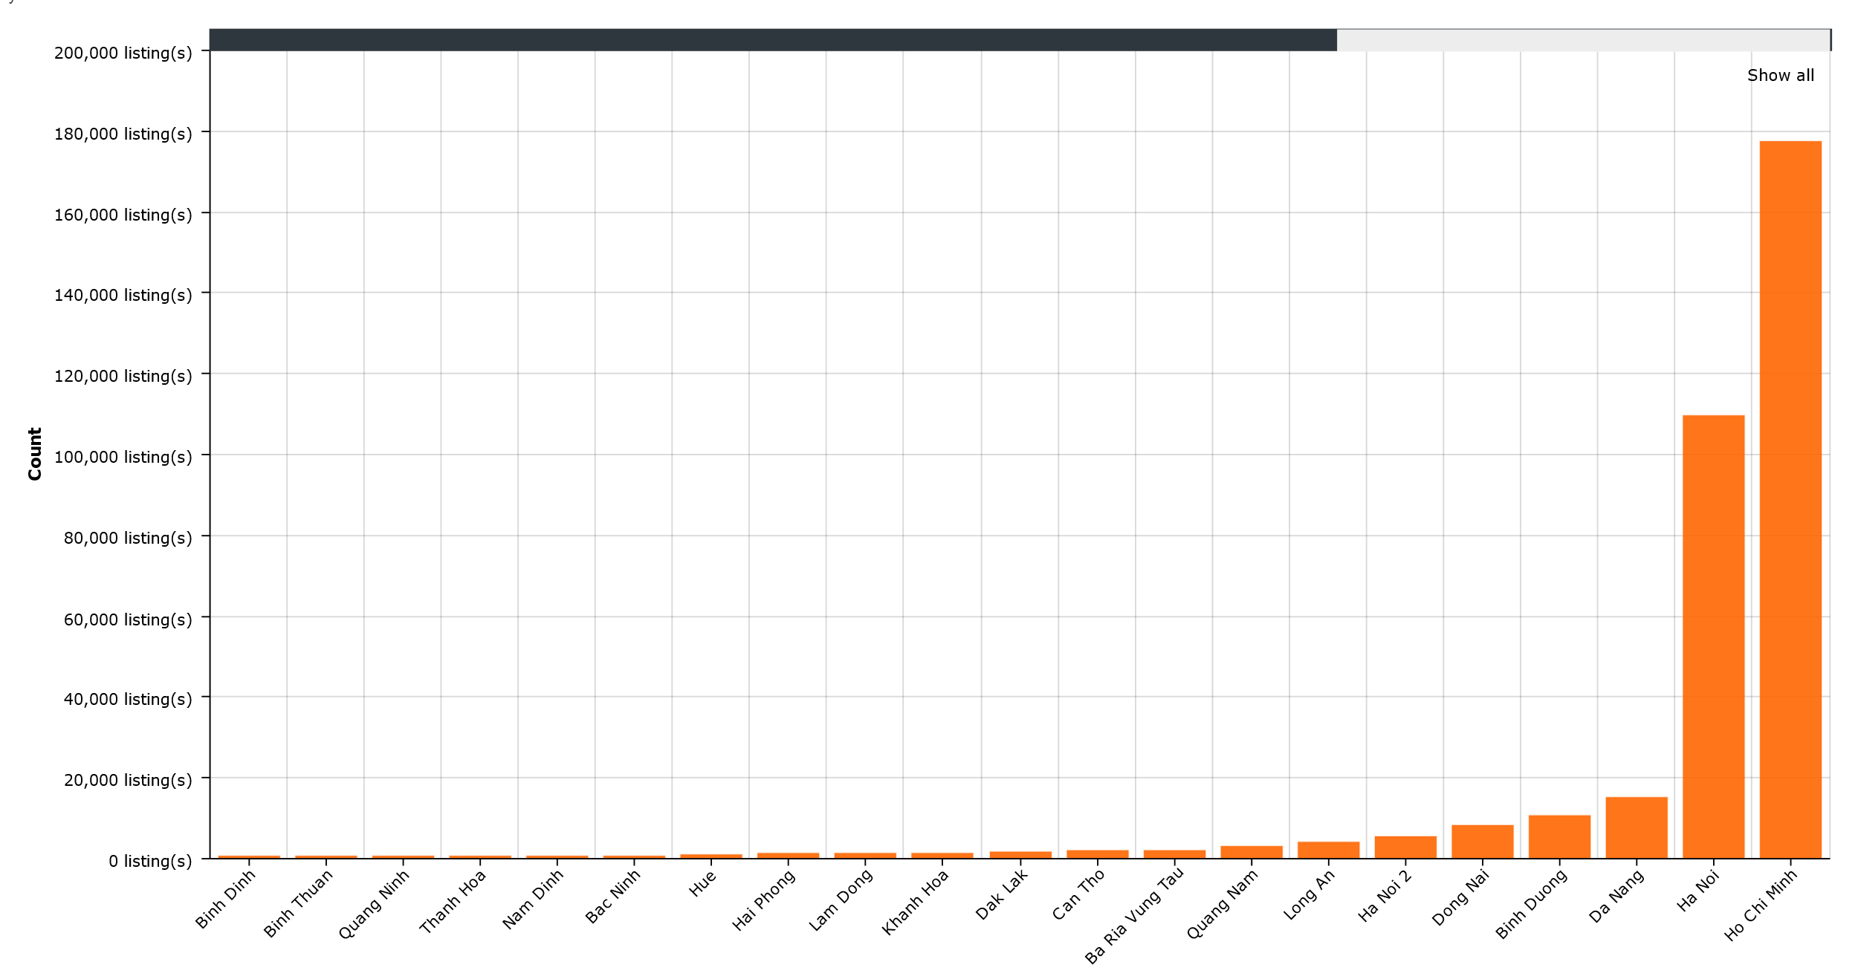

**Figure 31: Listing distribution for sale by province from November 2016 to June 2017**

**Figure 31** and

**Figure 32** show the distribution of listings for sale and rent in provinces of Vietnam. As observed above, the listings we scrape mainly belong to Ho Chi Minh and Hanoi, while other provinces have little to none listing(s). The lack of data in those provinces prevents us from having an accurate insight about their real estate’s market. Because of that, we decided to only focus on Hanoi and Ho Chi Minh city, each of which has around 177,643 (124,971 listings for sale, 30,042 listings for rent) and 109,585 (73,526 listing for sale, 30,869 listings for rent) listings respectively, which we deemed as enough to get a close insight.

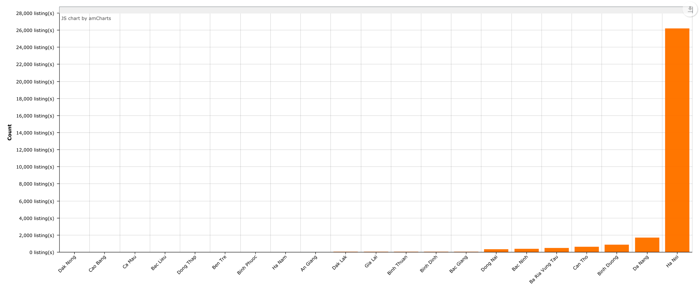

**Figure 32: Listing distribution for rent by province from November 2016 to June 2017**

**Error! Reference source not found.** shows the distribution of listings in districts of Ho Chi Minh city. In those districts, Binh Chanh had the biggest portion of real estates for sale (10.9% of Ho Chi Minh’s listings) with District 9 followed right behind (10.4%). These two districts are currently in the beginning of their development phase, since both of them either just had a new system of transportation infrastructure established (1A Highway and Provincial Highway 10 in Binh Chanh) or had a new industrial zone with the gathering of many big company (Tan Thuan Export Processing Zone in District 9). District 12 and Thu Duc also had a large number of real estate listings, albeit not as large as the two highest counties, rest at around 3/4 of their total number of

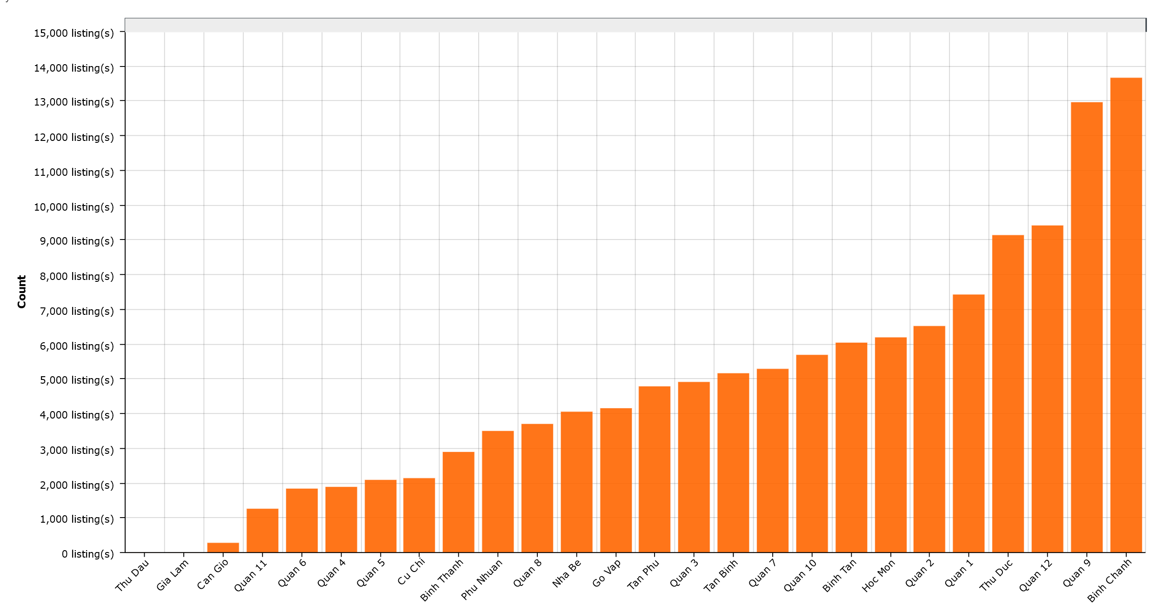

**Figure 33: Distribution of total house for sale in counties of Ho Chi Minh from November 2016 to June 2017**

listings, which is 7.5% and 7.3% listings respectively. The construction of the new metro system really boosts the popularity of District 12, making its real estate market developed. Thu Duc also received positive effect from the metro construction together with other existing transport infrastructure (Binh Trieu bridge, Binh Loi bridge, Tan Son Nhat – Binh Loi rim) had made it into a bustling market.The remaining districts did not have such a step decrease as the first four district. The real estate market in districts like District 1, 2, 10, 3, Tan Phu, Binh Tan, etc., which had had its infrastructure in place for a while but still had several projects in development phase had a moderate number of listings. These market is not as big as the new developing district but is still quite active. We did not get any listings for Thu Dau and Gia Lam, which maybe because brokers did not use the pages we selected to post their info. Can Gio also had a significantly low number of listings.

**Figure 34: Distribution of listings for rent in Ho Chi Minh city from November 2016 to June 2017**

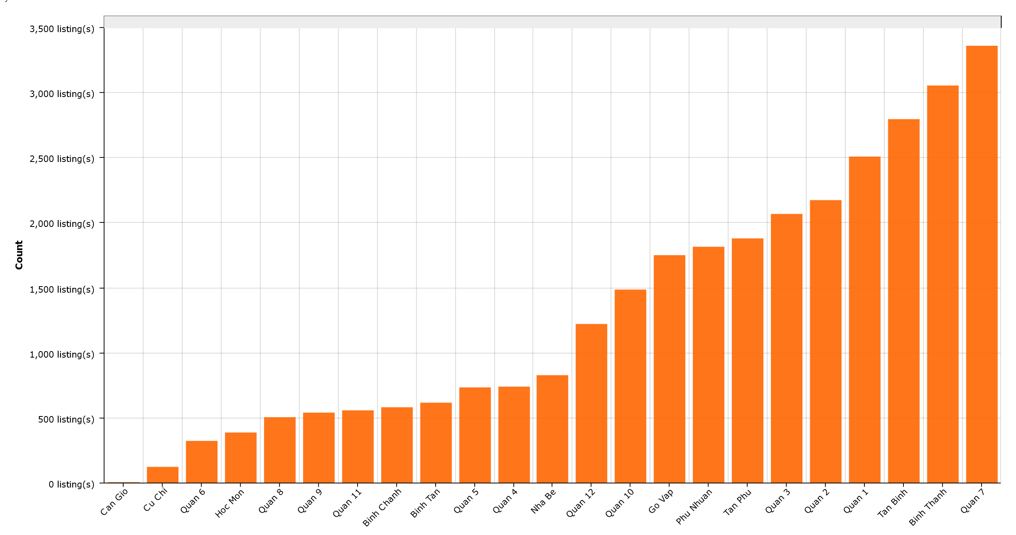

In **Error! Reference source not found.**, the listings distribution of real estate for rent is a bit different from real

estate for sale. The total listing is much less than that of real estate for sale (about 1/3), indicated that the market for rental real estate is not as big as its counterpart. Many real estate listings gather in the central part of the city and the east side, with the most note-worthy is District 7, possessed the most listings (11.1%), with many new apartment projects and many people joining in the housing rental service. Other central counties like District 1, Tan Binh, Binh Thanh, etc. also have relatively large number of listings. The suburban counties like Cu Chi, Can Gio, Hoc Mon have really small numbers of listings because of smaller need for rental house (either because not many workers gather there or because the house price is lower) and many of their transaction happened offline, without advertising on the net.

**Figure 35: Distribution of listings for sale in Hanoi from November 2016 to June 2017**

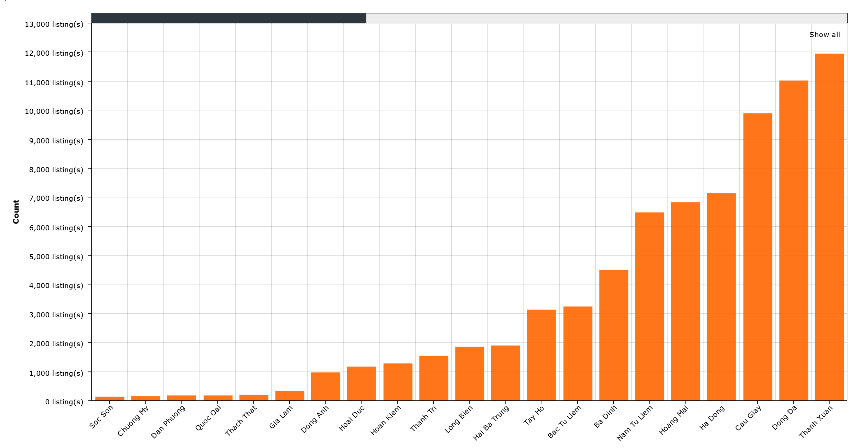

The real estate market in Hanoi is presented by Error! Reference source not found., and the real estate for sale’s pool is especially dense in the city’s center, with the most notable districts consist of Thanh Xuan, Dong Da, and Cau Giay, each of them had more than 9,500 listings, which made up 41% of all the listings in the city. Other center districts like Ha Dong, Hoang Mai, Nam Tu Liem also had a relatively large number of listings (9.7%, 9.3%, and 8.8% respectively). On the other hand, the suburban districts of Hanoi (Ba Vi, Son Tay, Chuong My, Thach That, etc.) had a very small number of listings (smaller than 1%). Hoan Kiem is a peculiar case, whereas even though it is in the central area of Hanoi, its number of listings is quite small (1.7%).

**Figure 36: Hanoi's rental listings distribution between November 2016 and June 2017**

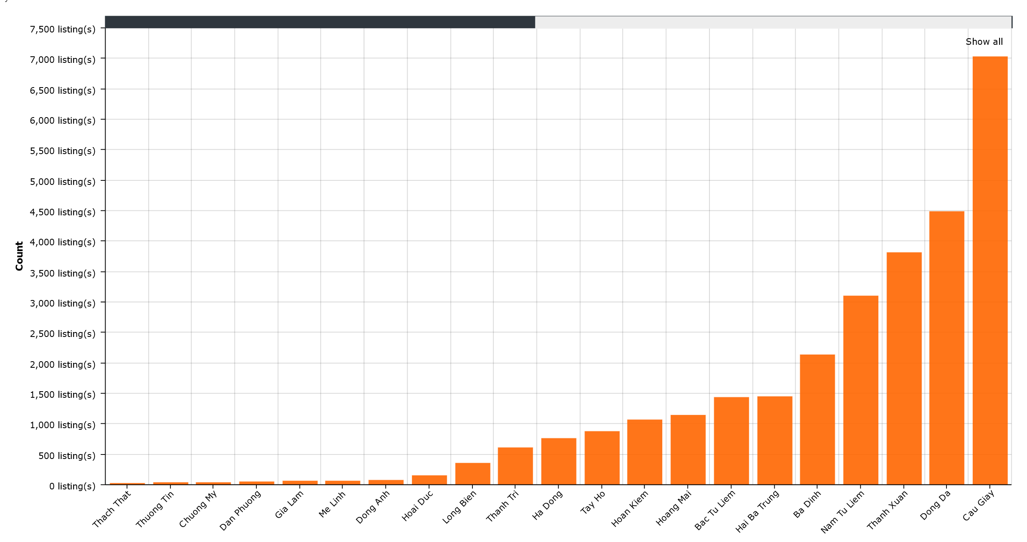

The rental housing market is quite similar to its counterpart in Hanoi, with a slight different that there is a sharp difference in number of listings between Cau Giay, the densest districts, with the rest. The center, urban districts (Hai Ba Trung, Dong

Da, Thanh Xuan, etc.) also have a bigger pool comparing with its suburban counterparts.

*RQ2: What is the distribution of real estate type in a region? What kind of real estate is the most popular in recent years?*

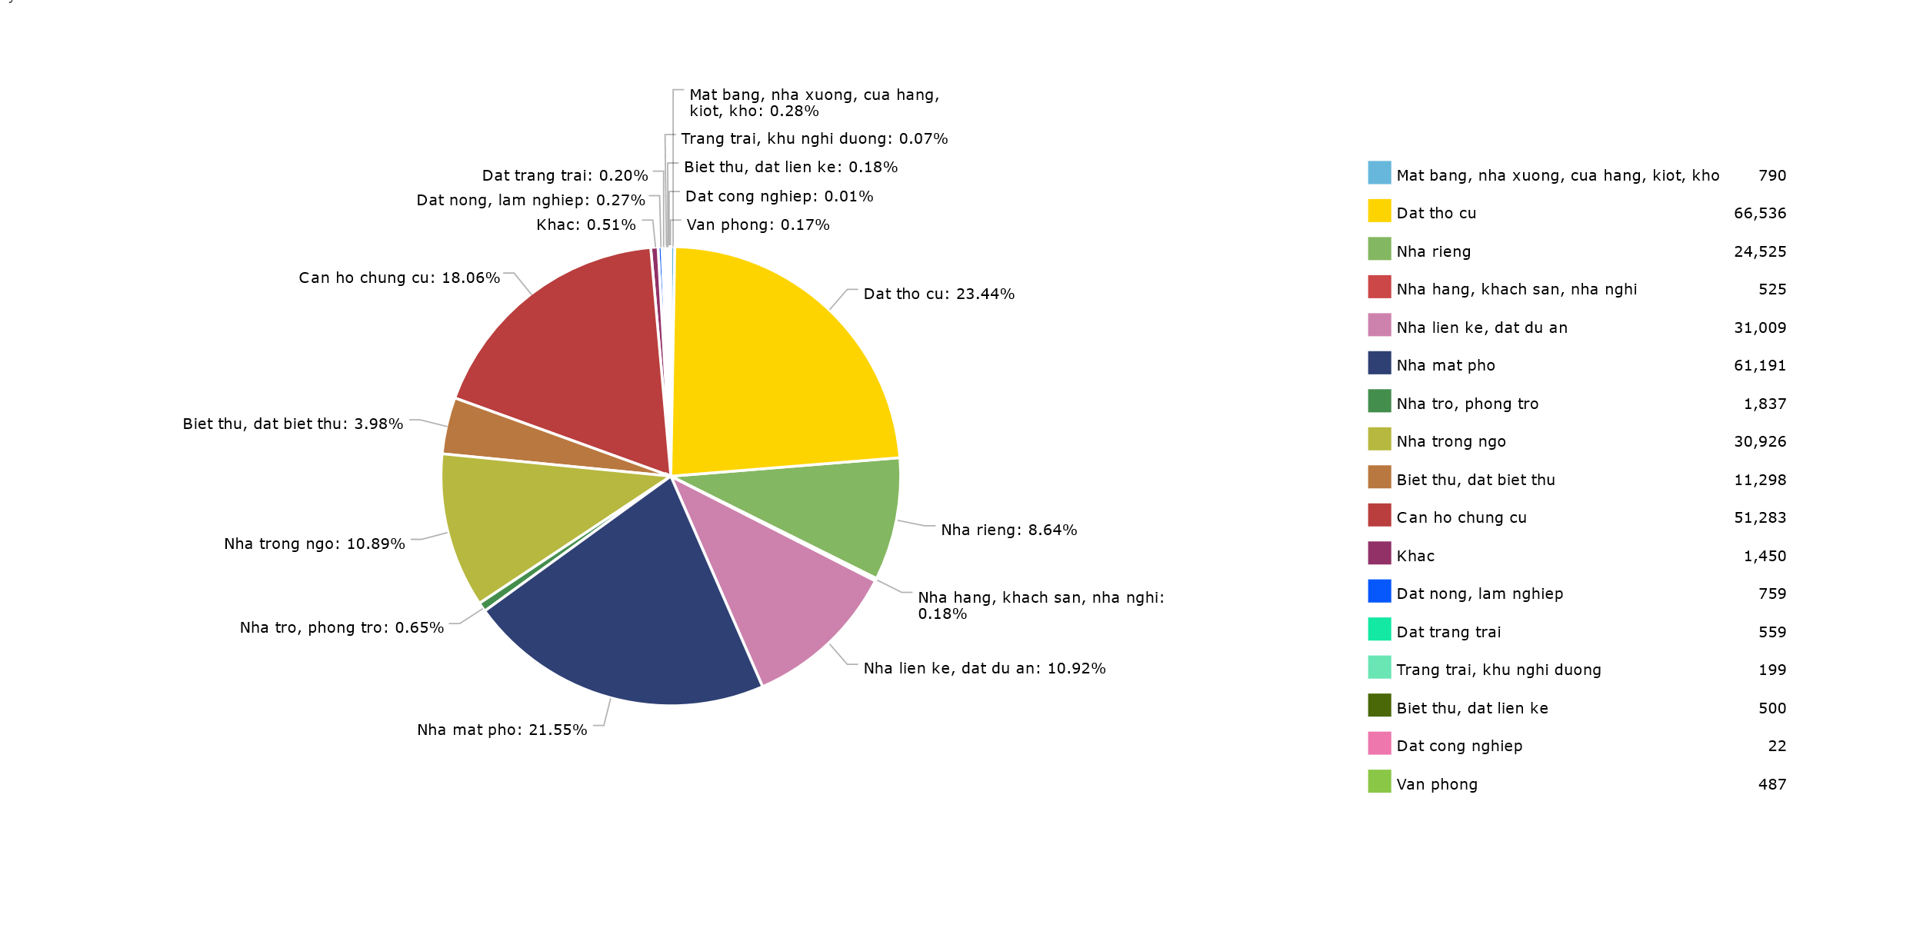

**Figure 37: Real estate for sale categorized by type in Vietnam between November 2016 and June 2017**

As we can see in an overview of the market of real estate for sale in **Figure 37**, the distribution of listings between real estate type is very unbalanced. This is understandable because some properties had a much higher demand (residential properties like residential lands, apartment, townhouses, etc.) since each family needs at least one, while other special properties used to do business or for leisure had a much smaller market (Office, Factory, Garage, Villa, etc.) since not everybody need one or able to afford one. The most dominant real estate type including: residential lands (23.44%), townhouses (21.55%), apartment (18.06%), alley houses (10.89%), project lands (10.92%). To get a more specific insight, we investigated further into the distribution of Hanoi, Ho Chi Minh, and some of the districts with large real estate market of them.

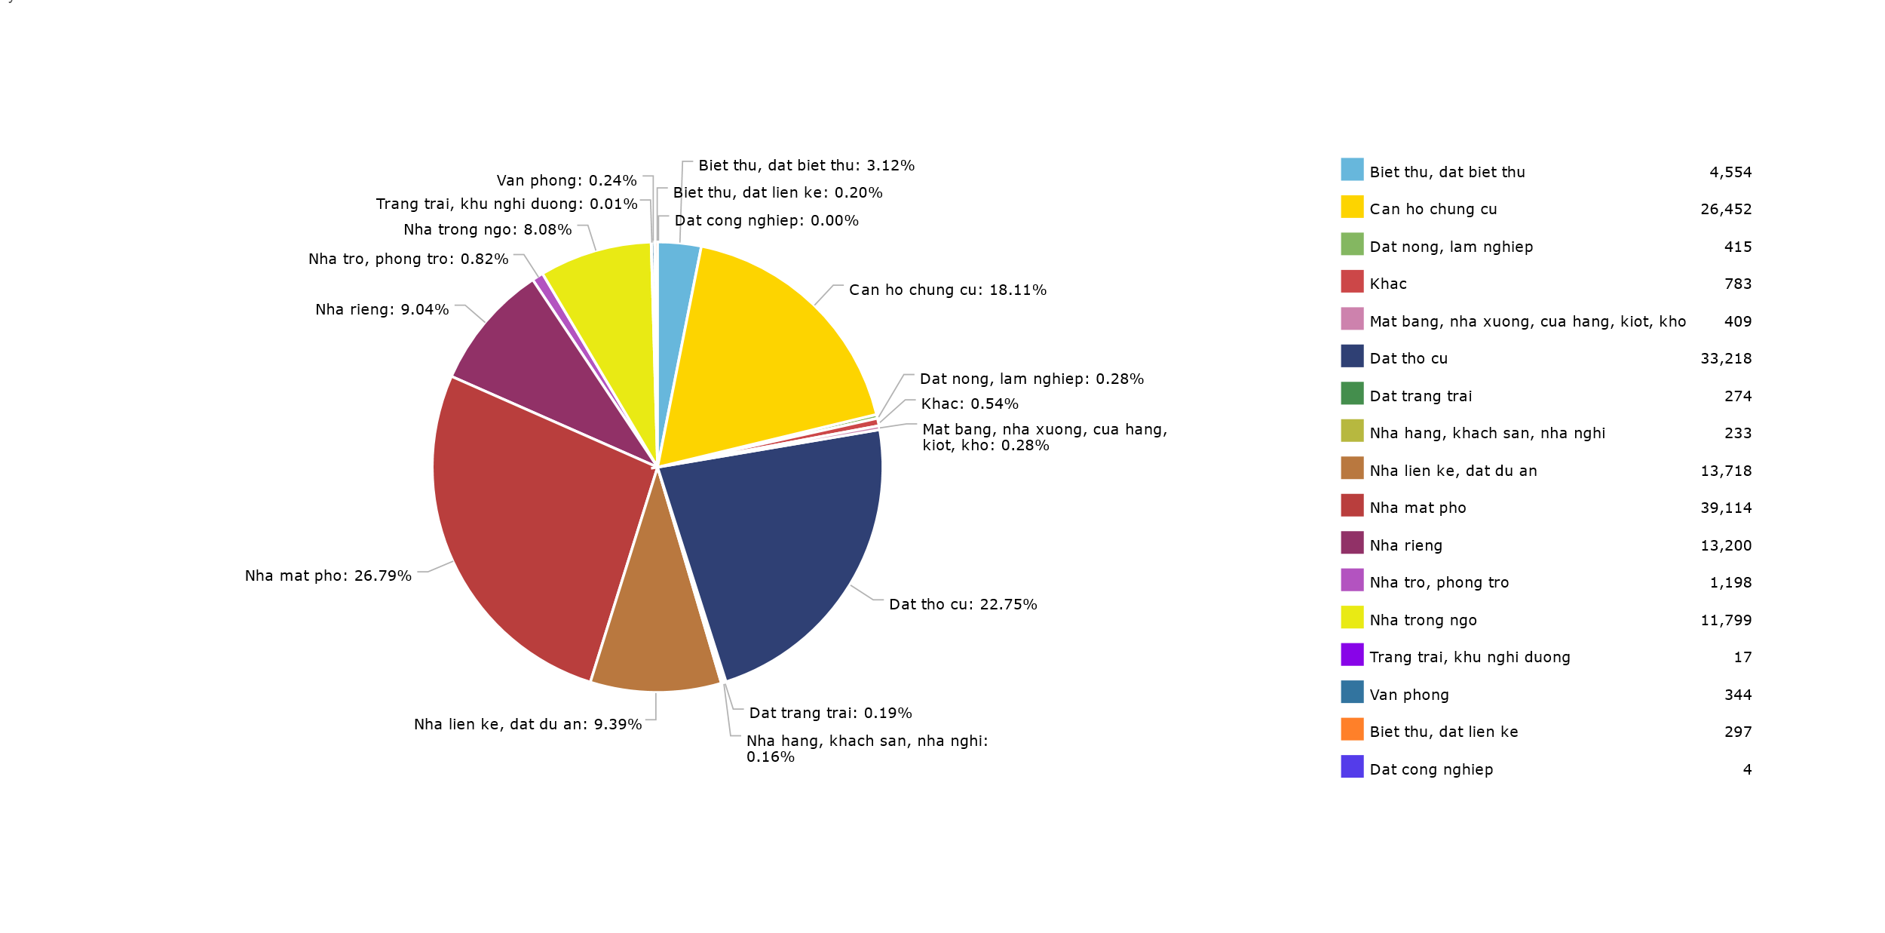

**Figure 38: Ho Chi Minh's real estate listings for sale by type between November 2016 and June 2017**

# 

From **Figure 38**, which showed the real estate listings for sale grouped by type, we can see that the real estate market in Ho Chi Minh has 7 significant types:

Townhouses (26.79%), residential lands (22.75%), apartments (18.11%), project lands (9.39%), detached houses (9.04%), alley houses (8.08%), and villa (3.12%). There are other remaining types, though each of them did not even make up 1% of the whole market. While there are many types of real estate, not all districts had a market for them, or at least, not significant. Most urban districts of Ho Chi Minh had town houses or/and apartment projects take a large portion in their market: District 1 (75.61% for town houses), District 10 (49.99% for town houses, 13.10% for apartments), Binh Thanh (26.14% for town houses, 32.08% for apartments), etc. On the other hand, most suburban districts had residential lands as the most dominant real estate type: Cu Chi (56.52%), Hoc Mon (40.34%), Thu Duc (36.32%).

The first district of Ho Chi Minh that we focused in our scope is Binh Chanh, which had the highest number of listings for sale in Ho Chi Minh. Since Binh Chanh is a large district, we can see from **Figure 39**, which represent the real estate market of Binh

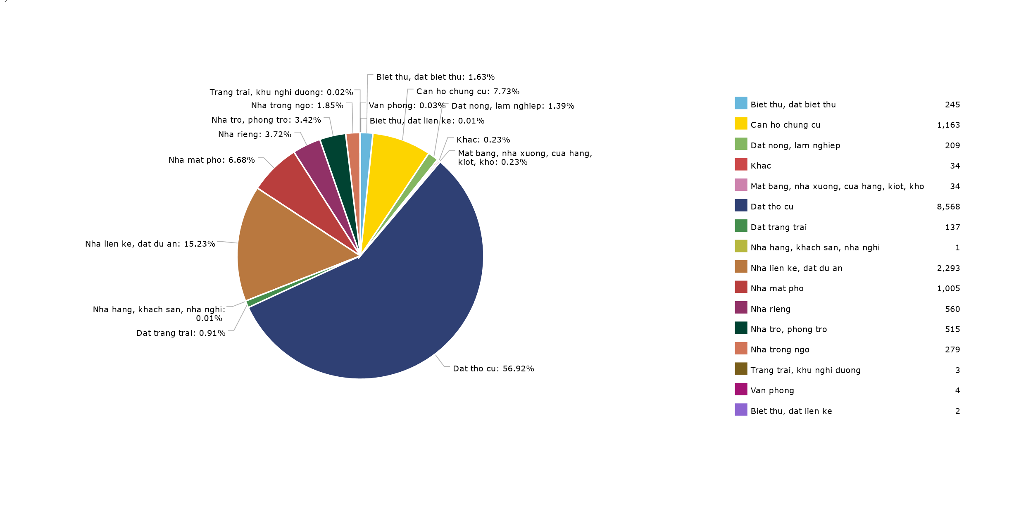

**Figure 39: Binh Chanh's real estate listings for sale by type between November 2016 and June 2017**

Chanh by types, that there is a wide variety of real estate type, from hotel, farm lands,

garages to residential lands, villa, and town houses. Overall, residential lands dominated the market and take up to 56.92%. This conform to reality since Binh Chanh is a large suburban district with lots of free lands. With the recent establishment of many transportation infrastructure like: A1 route and Provincial Highway 10 connecting Binh Chanh with Duc Hoa Industrial Zone, Nguyen Van Linh road connecting A1 route to District 7, Vo Van Kiet road connecting District 2 and Dong Nai, etc., the real estate market in Binh Chanh had become much more vibrant. Other than residential lands, there is also some new project lands (An Lac Resident, New Life Resident) and apartment projects (HQC Plaza, South Saigon Complex), which take up 15.23% and 7.73% respectively.

**Figure 40: District 1's real estate listings for sale by types between November 2016 and June 2017**

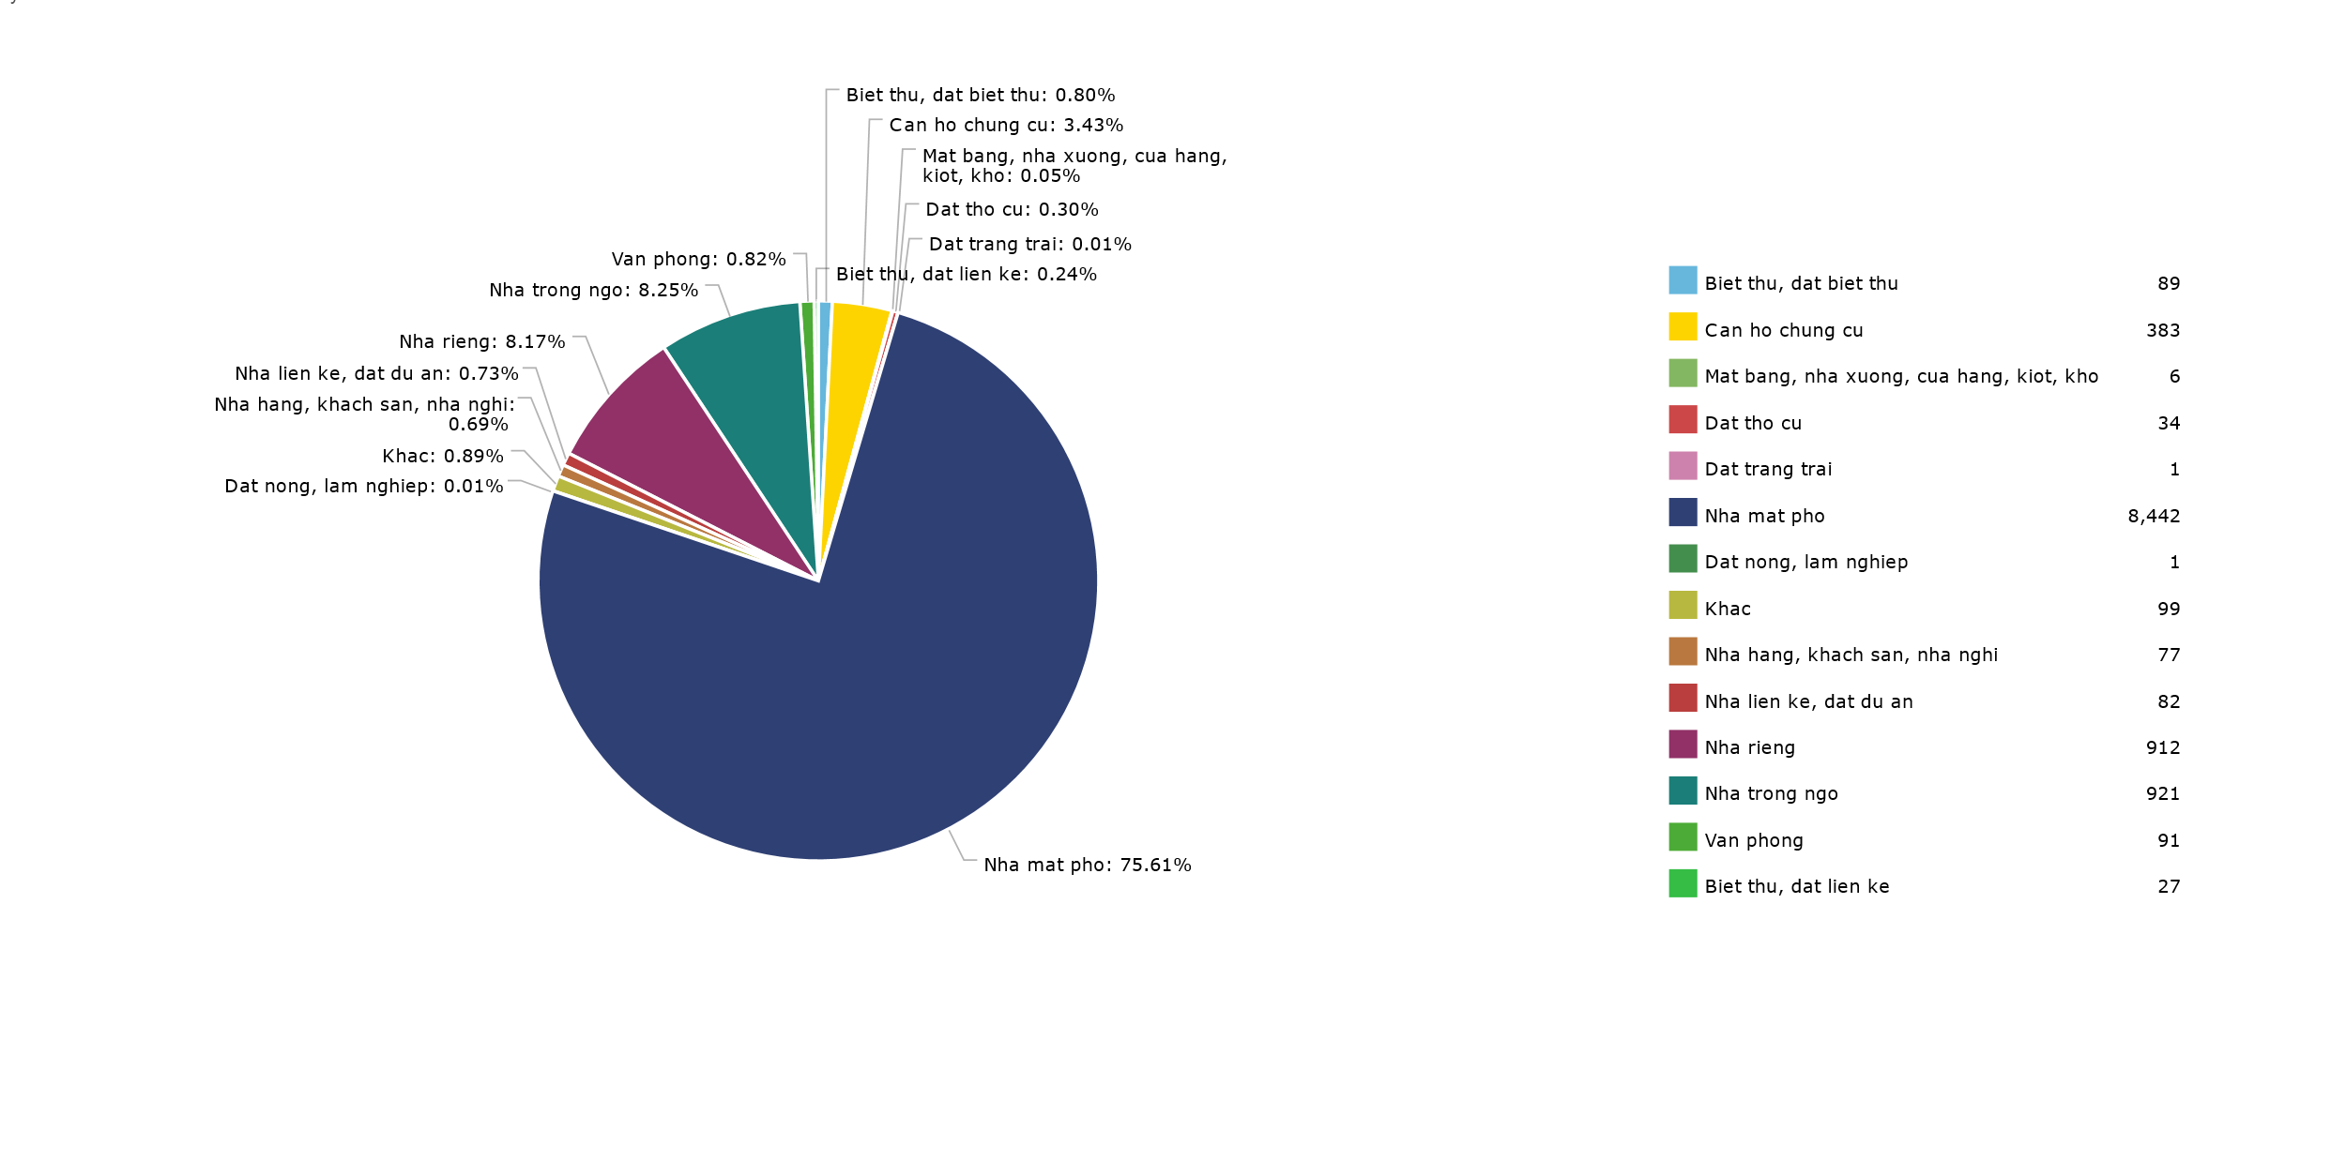

Another interesting district in Ho Chi Minh regarding real estate for sale is District 1, with the number of listings stood at third place, after Binh Chanh and District 9**. Figure 40** represents District 1’s real estate market grouped by type. Different from Binh Chanh, District 1 is an urban district that is regarded as one of the central districts of the city. A large portion of the market is town houses (75.61%), with some listings for alley house (8.25%), detached house (8.17%), and apartment (3.43%). Apart from the types above, there are a few other less significant types that did not even make up 1% of the market.

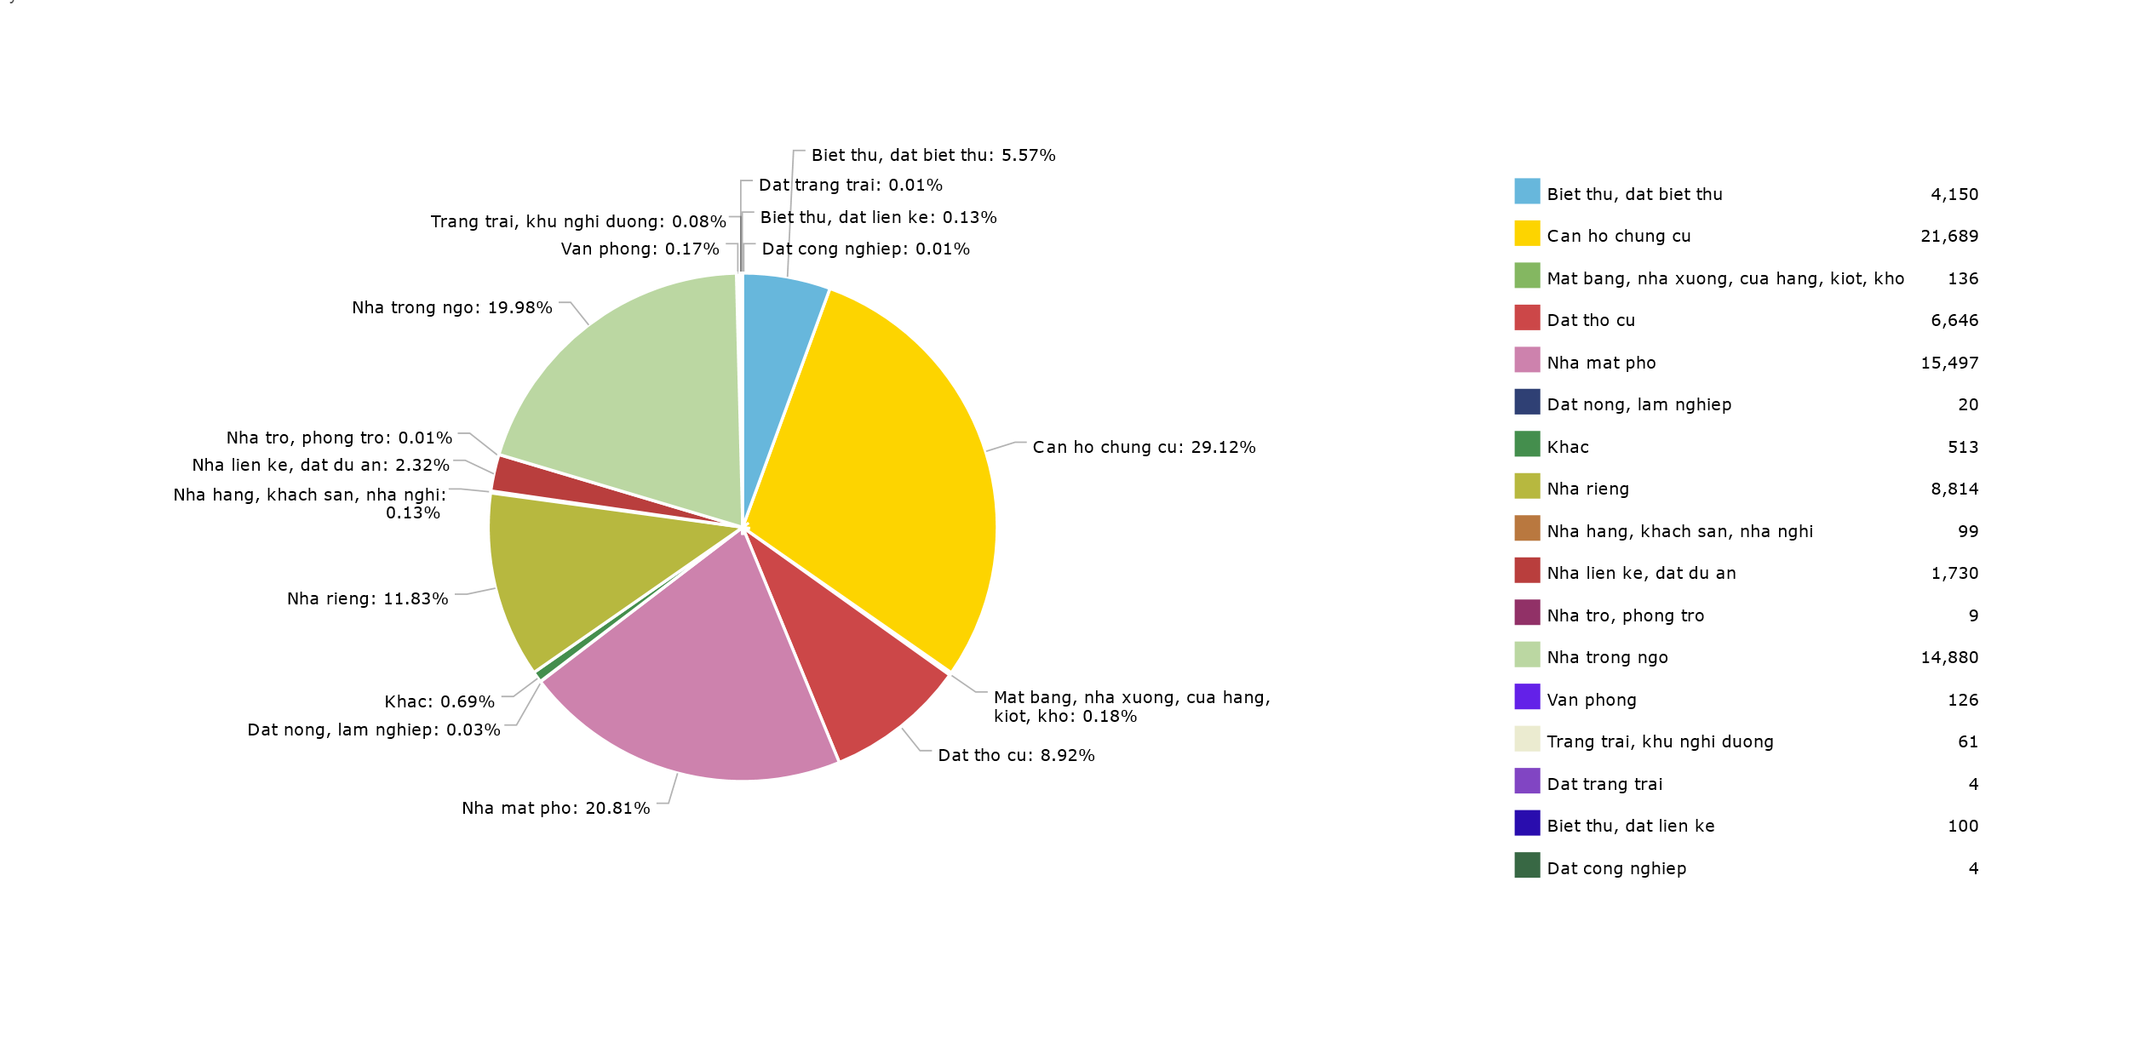

**Figure 41: Hanoi's real estate listings for sale by type between November 2016 and June 2017**

Similar to Ho Chi Minh, the seven most significant real estate types in Hanoi are: apartment (29.12%), town house (20.81%), alley house (19.98%), detached house (11.83%), residential lands (8.92%), villa (5.57%), and project lands (2.32%). Different from Ho Chi Minh, Hanoi’s real estate market had a much bigger portion of alley houses and a smaller portion of residential lands. Most urban districts in Hanoi had its listings belonged mostly to either apartment, town house, or alley house. There is some variation in distribution, where either one of them is more focused: Dong Da (36.41% for alley house, 32.90% for town house, 8.88% for apartment), Cau Giay (32.43% for apartment, 24.58% for town house, 19.78% for alley house), Nam Tu Liem (54.57% for apartment, 7.87% for town house, 7.35% for alley house), Ba Dinh (33.91% for town house, 30.89% for alley house, 11.48% for apartment), etc. For suburban districts in Hanoi, there are not many real estate listings in each of them. Still, from the few listings they had, most of them are residential lands (Thach That with 135 listings of residential lands from the total of 191 listings), which is similar to the distribution of suburban districts in Ho Chi Minh.

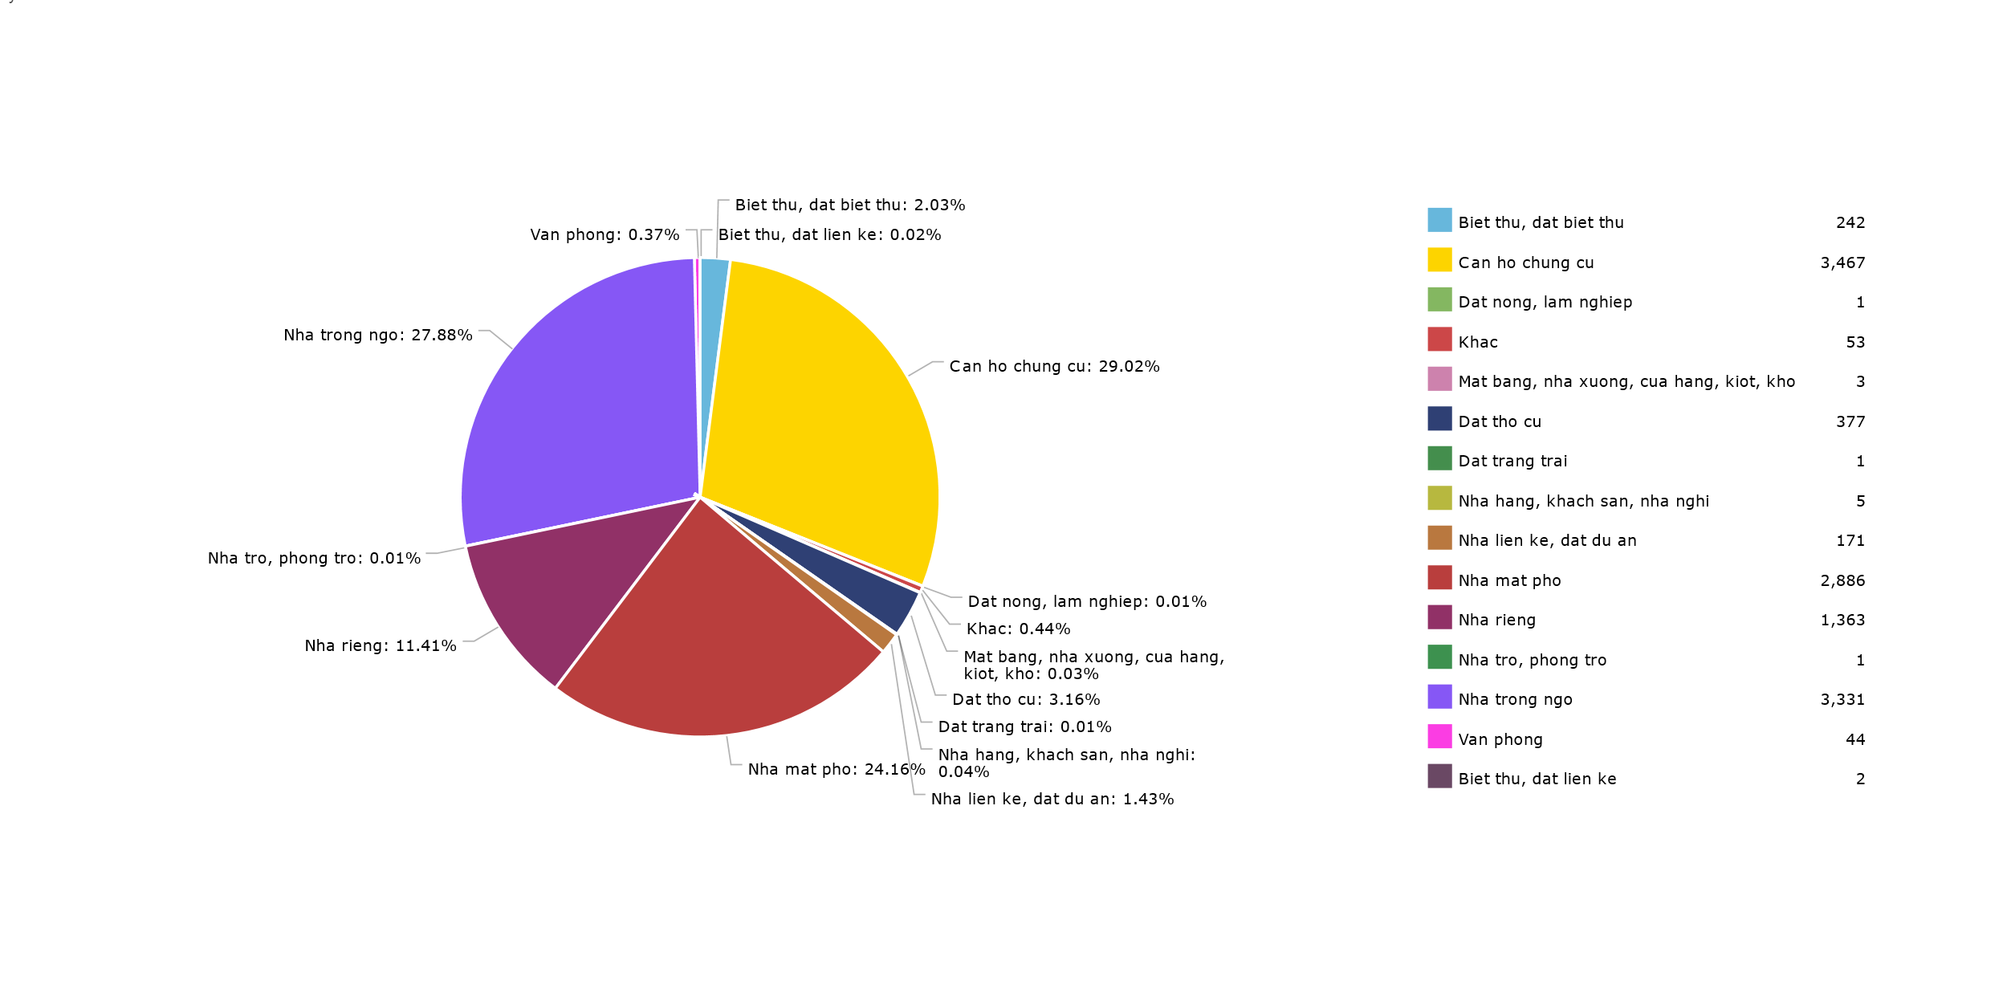

**Figure 42: Thanh Xuan's real estate listings for sale by type between November 2016 and June 2017**

As we can see from **Error! Reference source not found.**, Thanh Xuan is the urban district with the largest real estate’s pool in Hanoi. From **Figure 42**, we see that the three most dominant real estate types in Thanh Xuan are: apartments (29.02%), alley houses (27.88%) and town houses (24.16%). Since it is an urban district in the center of the city, it is understandable that there are many prosperous apartments project and town houses for sale. On the other hand, since Thanh Xuan is an old district, it had lots of alleys for human’s usage. These small streets formed in the time that cars or big carriage were not a large portion of the transportation. Because of that, there are also many alley houses in Thanh Xuan.

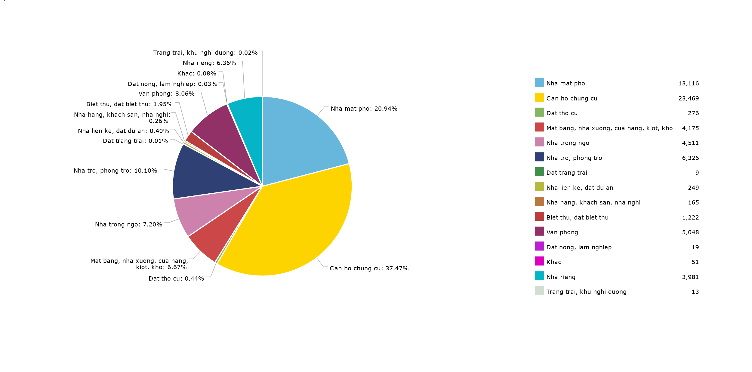

**Figure 43: Real estate's listings for rent by type in Vietnam between November 2016 and June 2017**

For rental housing market, some real estate types that had insignificant number of listings for sale now have a sharp increase in number. The real estate type with the largest market share is no longer residential lands but apartment (37.47%). Other significant types are: town house (20.94%), room for rent (10.10%), office (8.06%), alley house (7.20%), garage/kiosk/store front (6.67%), detached house (6.36%), and villa (1.95%). Since the number of listings of rental housing is a lot fewer comparing to real estate for sale, we will only investigate on the province level.

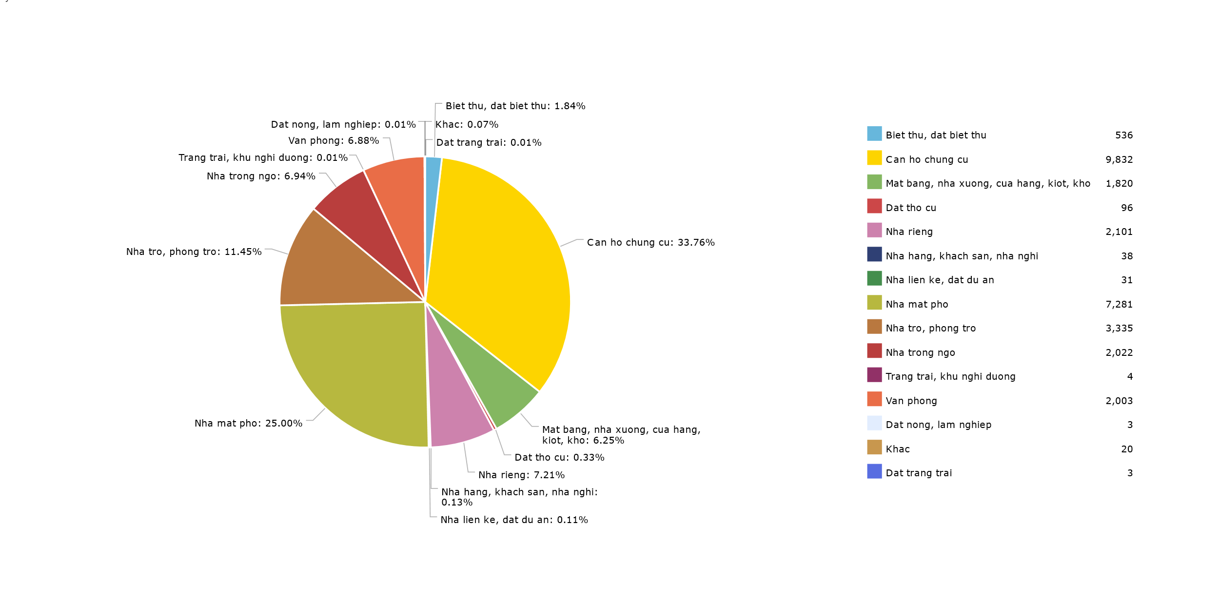

**Figure 44: Ho Chi Minh's real estate listings by type between November 2016 and June 2017**

In Ho Chi Minh, apartment is the dominant type of rental housing (33.76%), with a lot of existing apartment complexes or in construction. These apartments littered throughout the districts of Ho Chi Minh but in all of them, District 7 stands out as the district with the most listings for apartments (15.4% of total listings in Ho Chi Minh). Another dominant type is town houses, which mostly belonged to urban districts like District 1 (16.7% of total town house listings), District 3 (11.2%), District 10 (9.4%), etc. To our surprise, even though rooms for rent is a common need for both university students and workers alike, it only took up a portion of about 11.45% of the whole market. These listings mostly belong to Tan Binh, District 7, Binh Thanh, District 10, District 3, and Phu Nhuan (15.3% , 12.5%, 11.1%, 10.2%, 8.96%, and 8% respectively in 3,335 total listings).

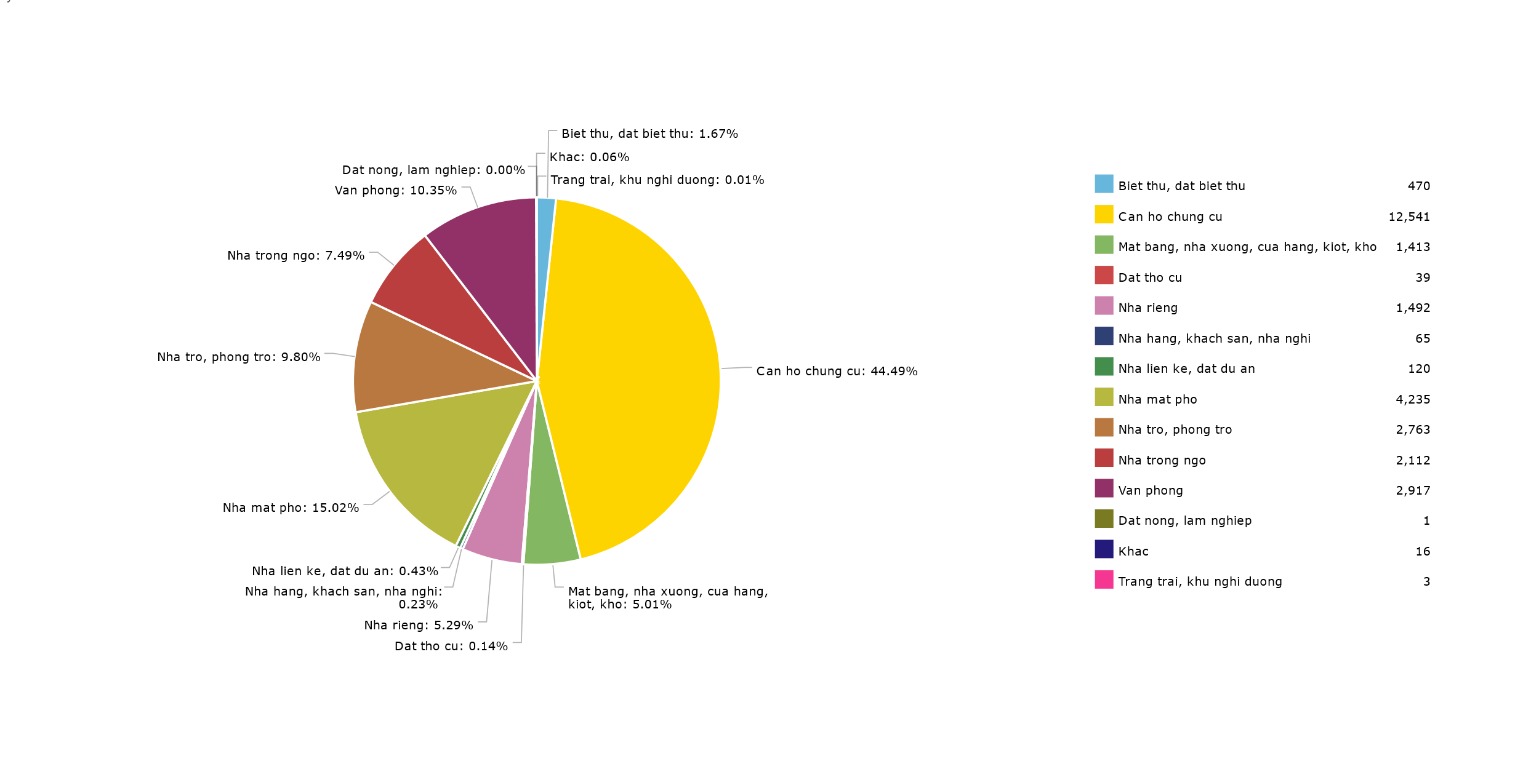

**Figure 45: Hanoi's rental housing by type between November 2016 and June 2017**

**Figure 45** showed Hanoi’s rental housing market by type. In Hanoi, apartment take a much bigger portion, almost half of the whole market (44.49%). Districts with the most listings of apartments are: Cau Giay (25.4%), Thanh Xuan (17.7%), South Tu Liem (15.8%). Town houses is right after apartment regarding the number of listings (15.02%), even though there is a large difference in number between them. The two districts with the largest number of listings in town houses are Dong Da, contributed 25.3% of total listings and Cau Giay, contributed 24.9%.

*RQ 3: What is the pattern of real estate price distribution in a specific region? What leads to the price distribution?*

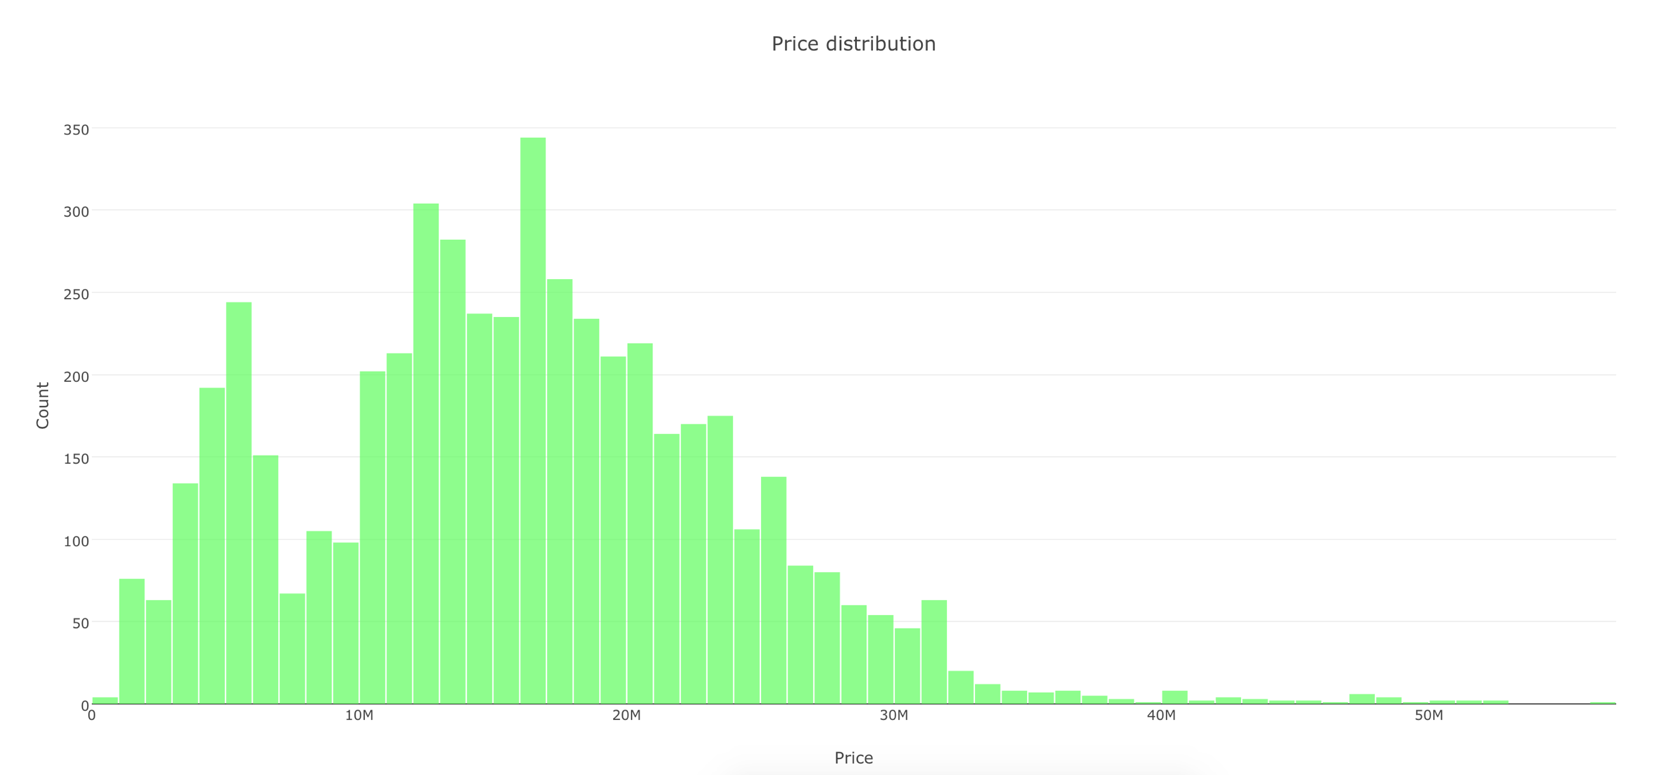

**Figure 46: Price distribution of residential land for sale in district 12 between November 2016 and June 2017**

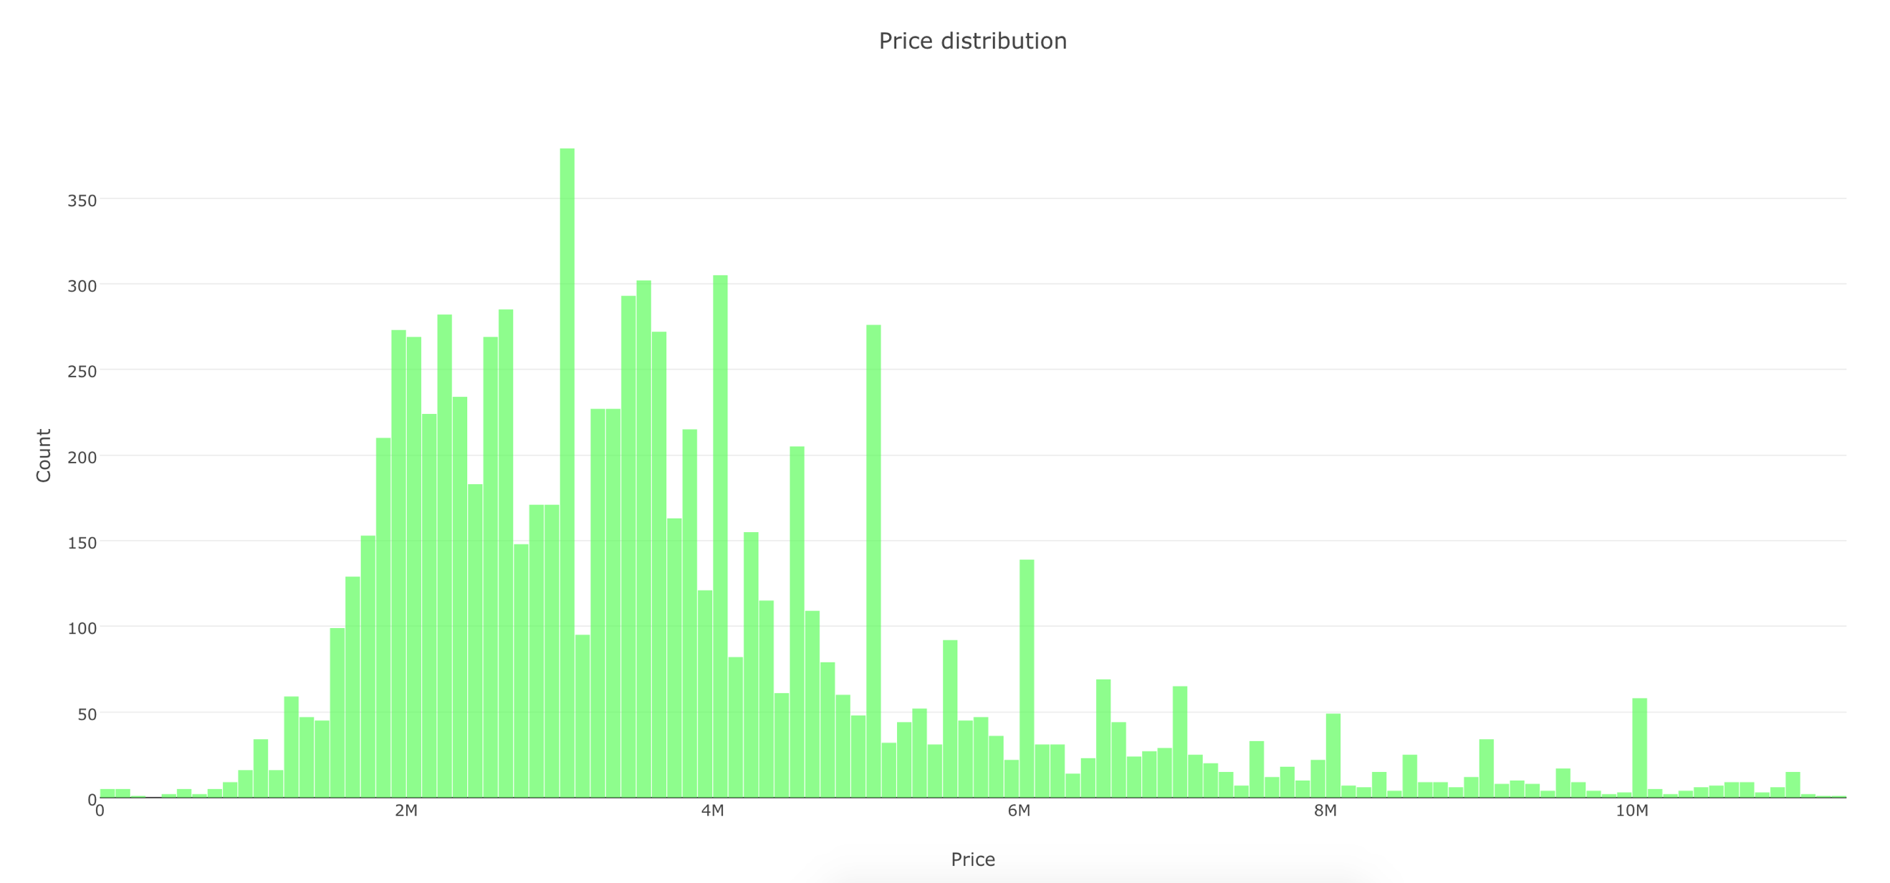

**Figure 47: Price distribution of residential land for sale in Binh Chanh between November 2016 and June 2017**

Recently, the suburban areas of Ho Chi Minh have been appeal to many investors, and the price of residential land in these areas has increased considerably. However, there is a huge difference between the price of residential land for sale in these areas. For example, with the price distribution of district 12 and Binh Chanh being presented by **Figure 46** and **Figure 47**, respectively. These suburbs make up the majority of housing items, and Binh Chanh is even the district containing the largest number of real estate items for sale. While the average price of residential land for sale in Binh Chanh concentrates on the range from 2 million to 4 million per square meter (**Figure 46**), that of district 12 will be from 12.5 to 18.5 million (**Figure 47**).

Even though belonging to the same district, there is still a huge gap between different wards. Taking district 9 as an example. While the price pattern of residential land in Long Thanh My gathers around 20 million per square meter (**Figure 48**),that of Hiep Phu is twice as much as Long Thanh My, at 40 million per square meter (**Figure 49**).

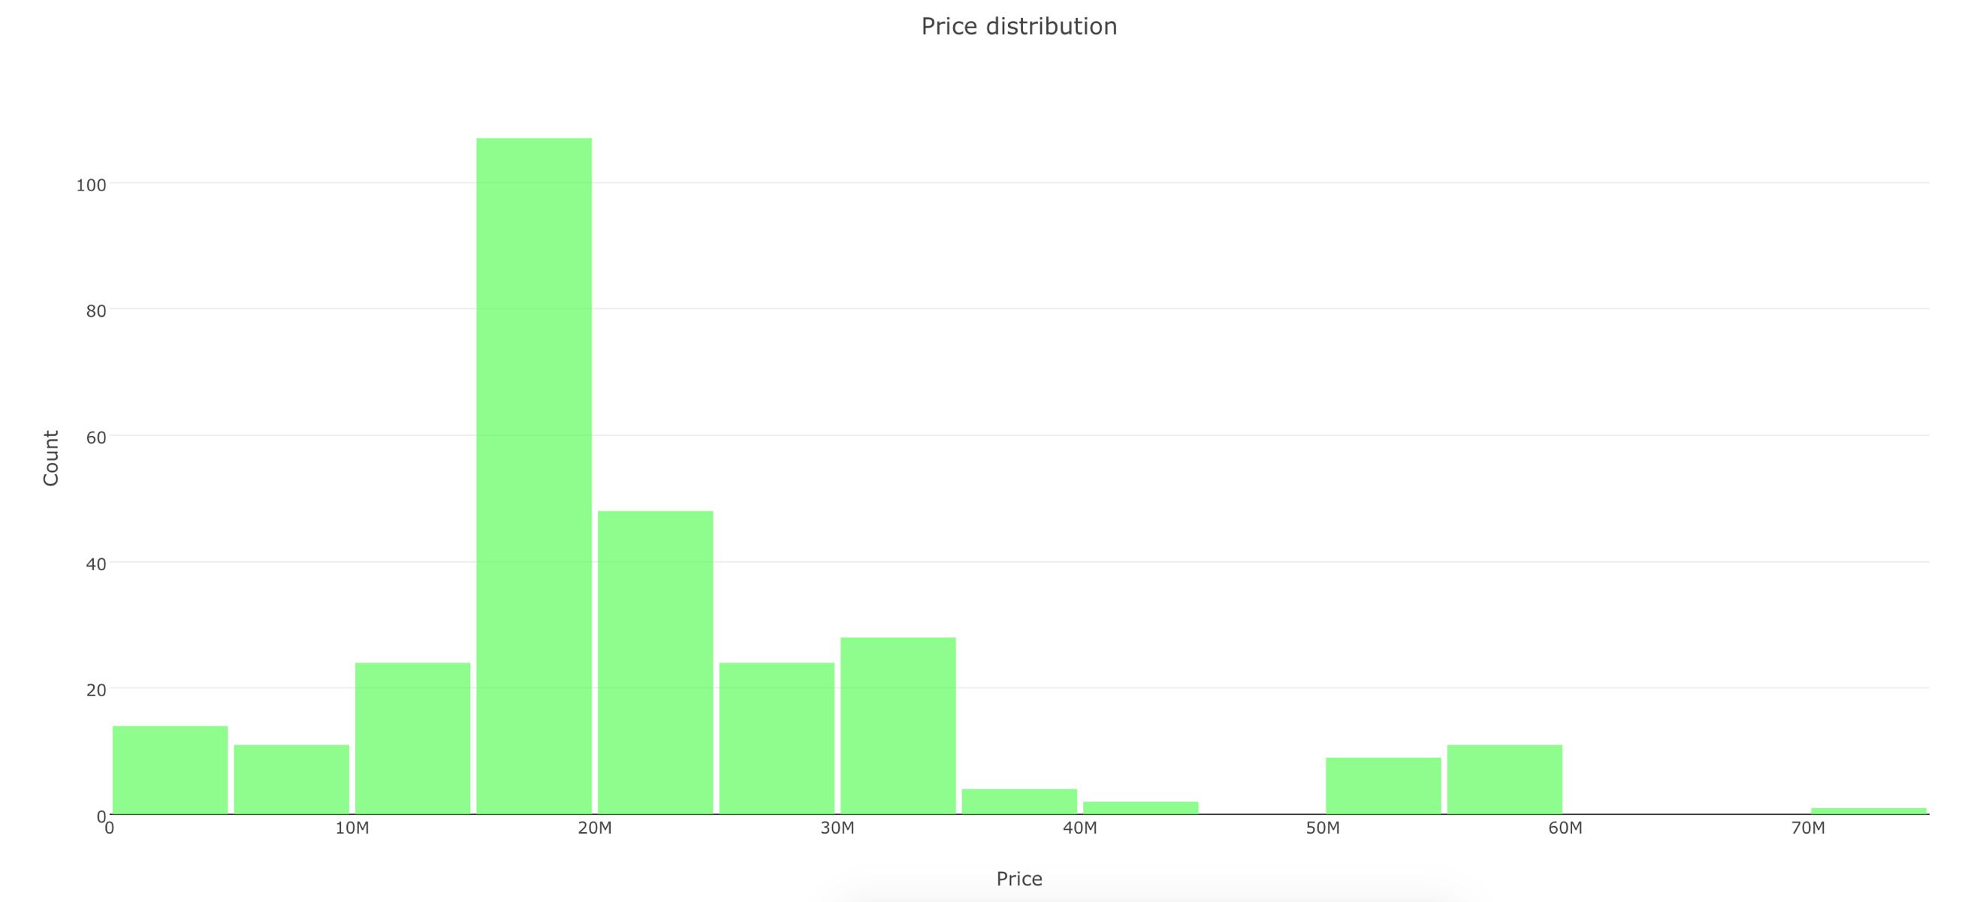

**Figure 48: Price distribution of residential land for sale in Long Thanh My between November 2016 and June 2017**

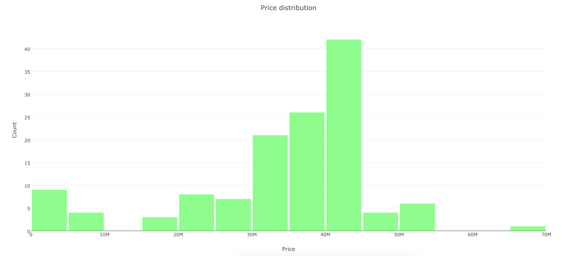

**Figure 49: Price distribution of residential land for sale in Hiep Phu between November 2016 and June 2017**

There are a number of reasons for this imbalance. The most commonly is due to the location of the wards. Being close to some key transportation infrastructures such as Mai Chi Tho and Pham Van Dong avenue, the average price of Hiep Phu has increased day by day. In addition to the development of infrastructure, the real estate market in district 9 has also become greatly attractive thanks to the support of the authorities on legal issues.

In contrast to suburban areas, the housing market of central areas of Ho Chi Minh has focused mainly on apartments. Due to home-ownership, Vietnamese usually prefer to have an asset belonging to themselves instead of renting from the others. However, the price of residential land and street house in central districts is too expensive for a person with average income to buy. As a result, apartments emerge as a feasible solution for the problem. For instance, in district 10, the average price of apartments primarily ranges from 40 to 45.5 million per square meter **Figure 50**. Despite extremely high price, most apartment projects in central areas such as district 10 are often sold out, even before being open for sale. The reason for this is because people want to live near the city centre. Moreover, compared with house, apartments are usually safer and have many services such as gym, swimming pool, supermarket, and school.

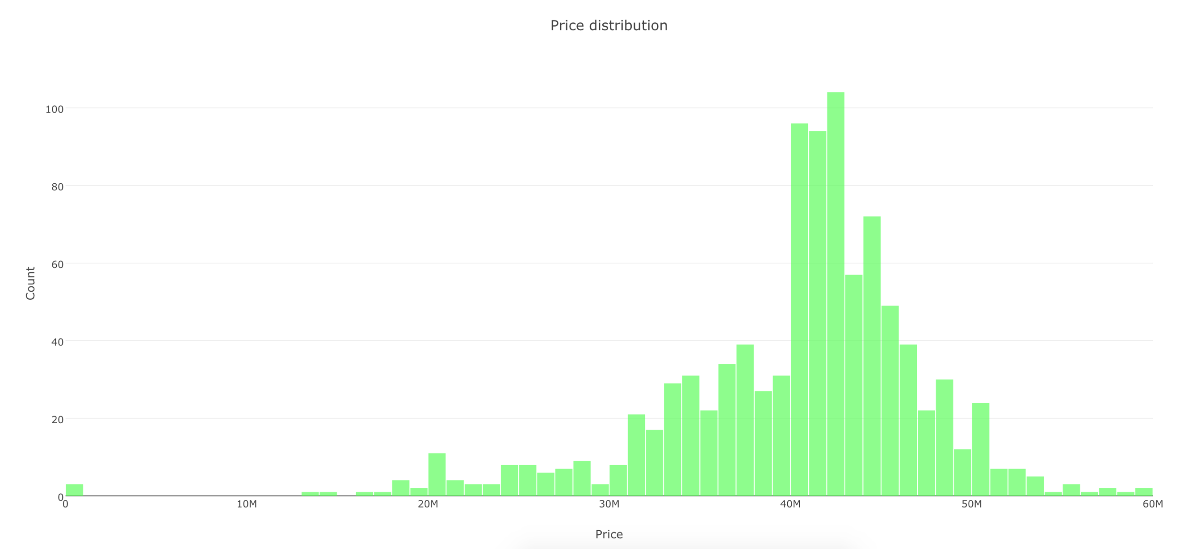

**Figure 50: Price distribution of apartments for sale in district 10 between November 2016 and June 2017**

In Hanoi, most real estate activities are still focus on apartments [figure 23 của An]. The market is dominated by western districts of the capital. For sale property market, the price pattern of apartments for sale in Tay Ho ranges from 19 to 27 million per square meter **Figure 51**.



**Figure 51: Price distribution of apartments for sale in Tay Ho between November 2016 and June 2017**

For rental housing market, due to the Vietnameses’ preference of living in street home which can be used to do business, the price distribution of street house for rent in some housing hotspots has reached a new peak. According to **Figure 52**, the price of street house for rent in Hai Ba Trung, a prime location in Hanoi Centre, mainly ranges from 450,000 to 750,000 VND per square meter.

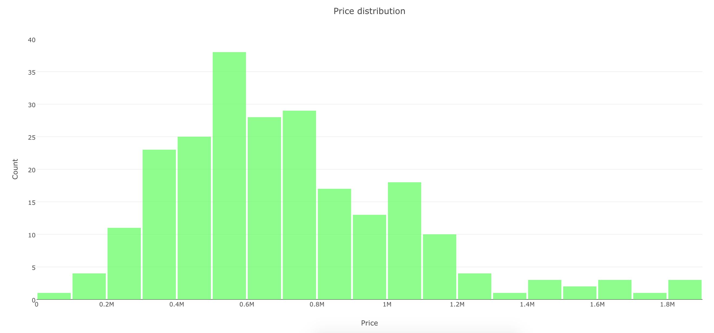

**Figure 52: Price distribution of street house for rent in Hai Ba Trung between November 2016 and June 2017**

*RQ 4: What is the price trend of a specific region in recent year?*



**Figure 53: Mean and median price of residential land for sale in Ho Chi Minh between November 2016 and June 2017**

According to **Figure 53**, while district 3 is the top district with the highest median and mean in price of residential land for sale, Binh Chanh, Cu Chi and Can Gio are the bottom districts with mean and median price having the lowest values. Nevertheless, from the beginning of 2017, Ho Chi Minh has experienced a spectacular price movement of residential land in some suburban regions such as District 9, Nha Be, Binh Chanh, and Cu Chi. The causes for is due to rumours that many governmentally large-scale projects will be implemented in these regions. However, according to a report of Department of Natural Resources and Environment, even though the price has shoot up dramatically, the number of residential land transactions is still small. As a result, this reminds experts the real estate market boom in 2007 [25].

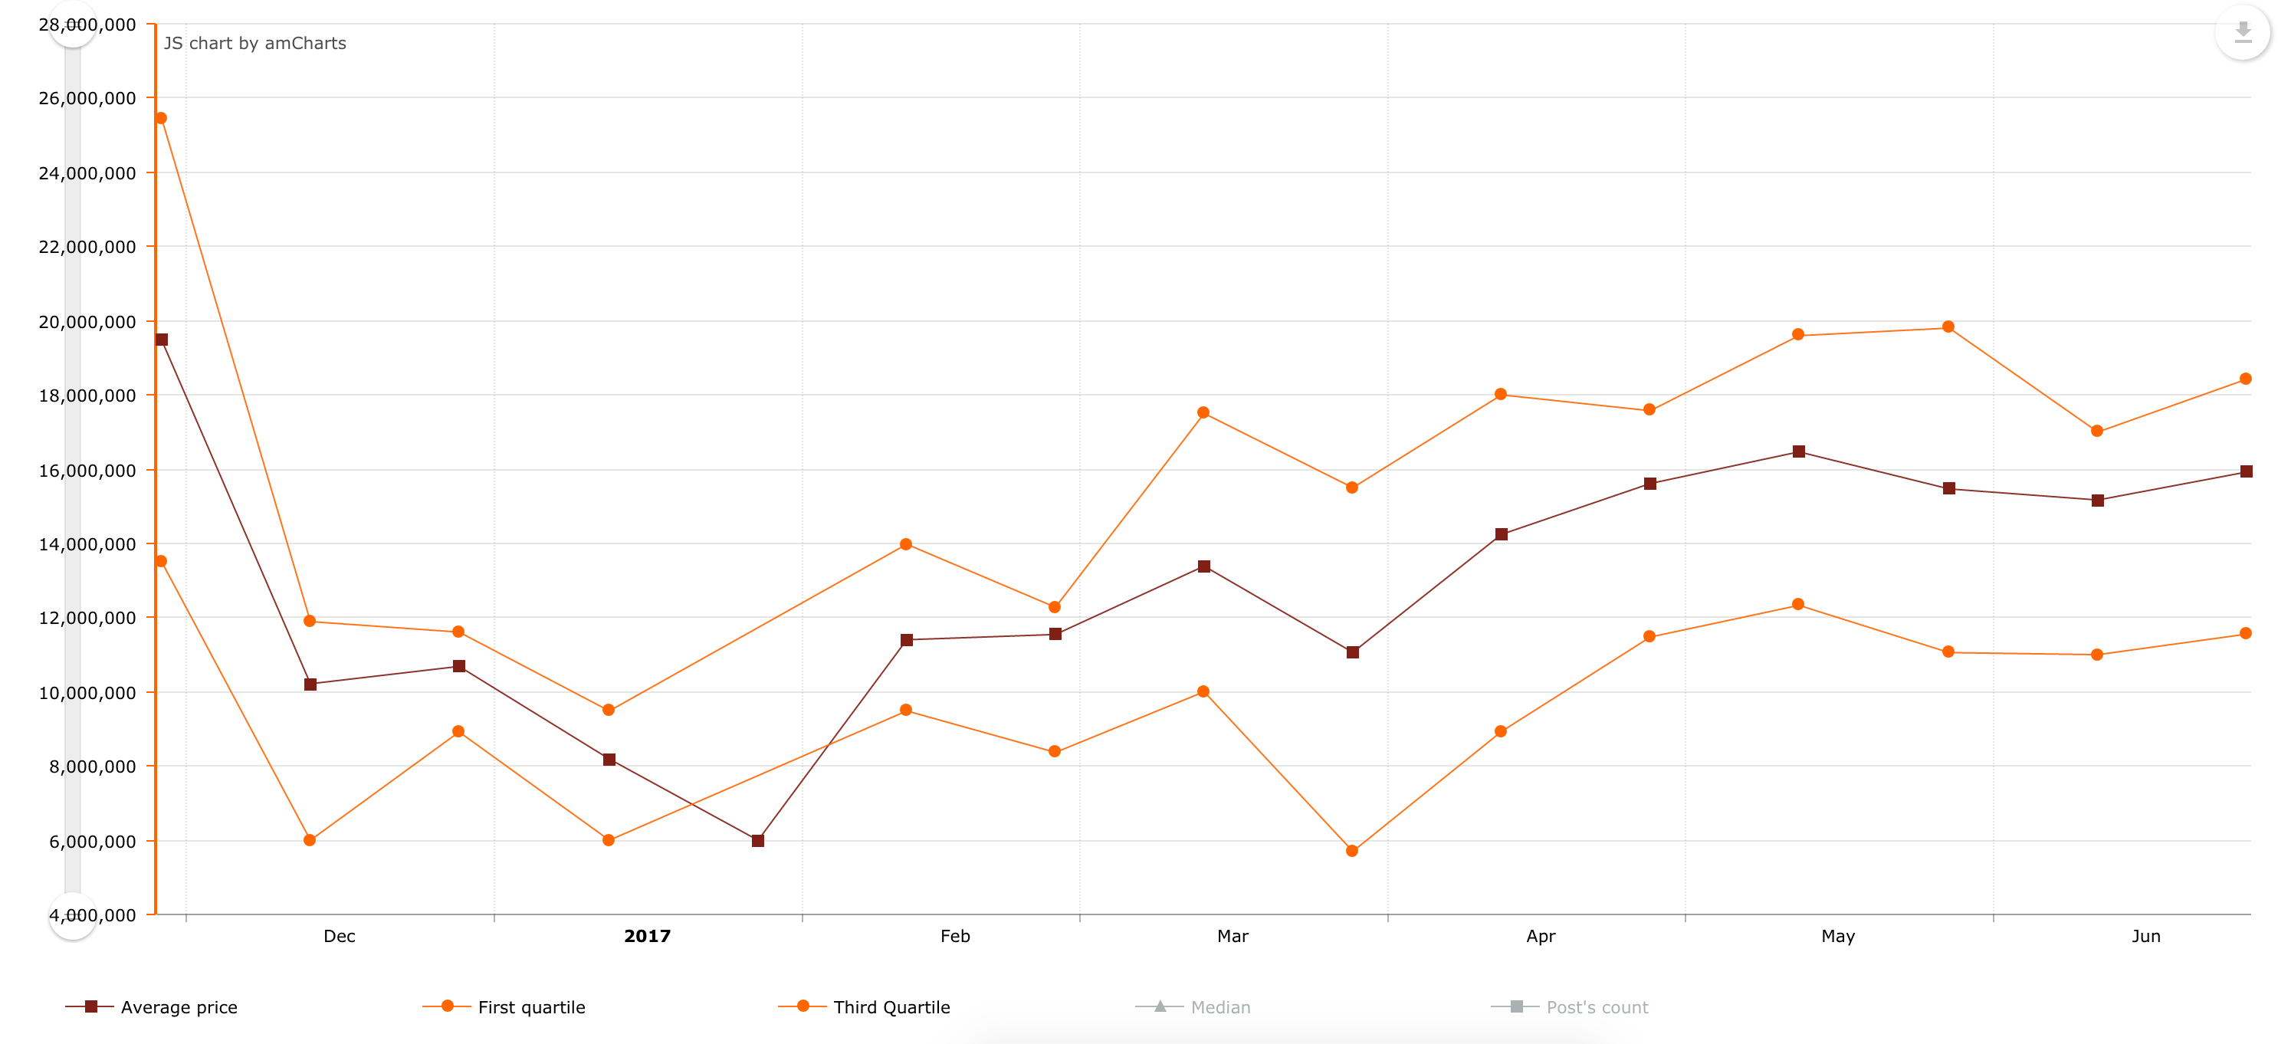

**Figure 54: Price trend of residential land for sale in Nha Be between November 2016 and June 2017**

According to **Figure 54**, showing the price trend of land in Nha Be, after a drop in the first month of 2017, the price of residential land has increased continually, and reached 16 million per square meter. The first quartile and third quartile also reached 11.5 and 18.4 million per square meter, respectively. The price trend shows potential to increase in the next months.

**.**

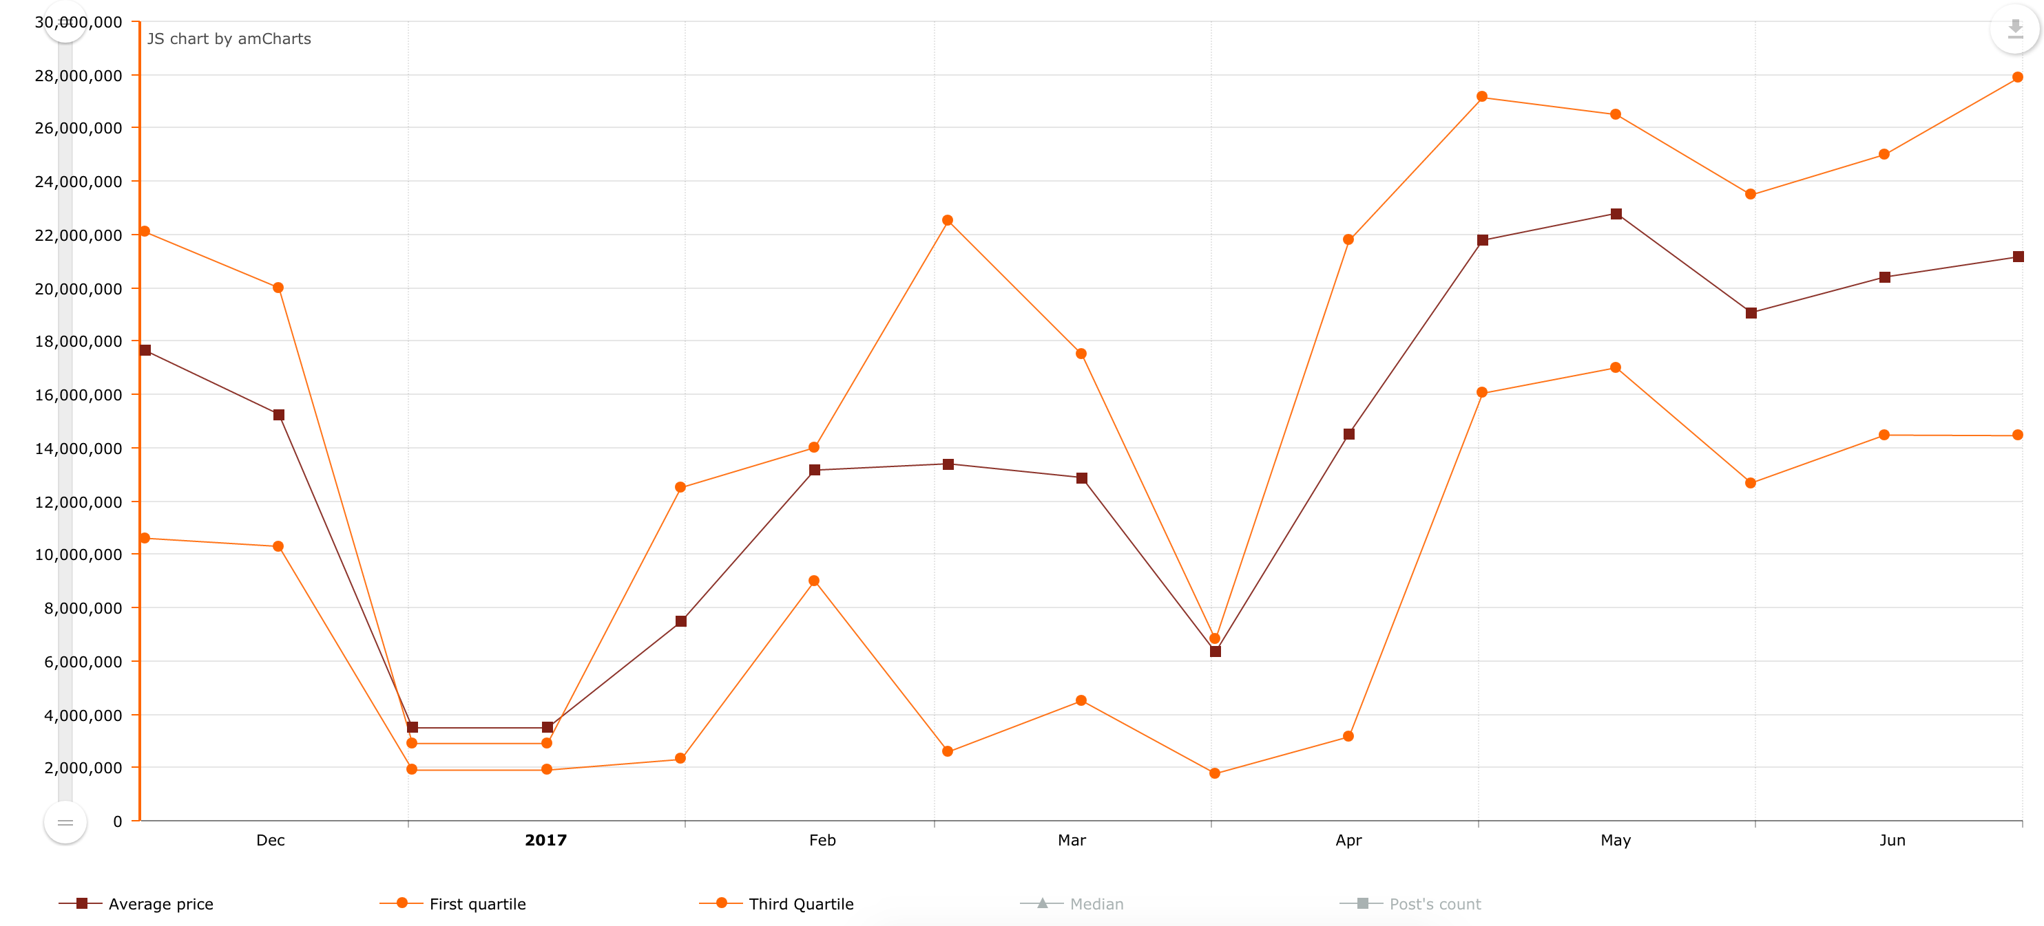

**Figure 55: : Price trend of residential land for sale in district 9 between November 2016 and June 2017**

The upward trend in price also happens in district 9. Due to many the development of transport connectivity and infrastructure systems such as highway and metro, the price of residential land in district 9 has reached nearly a peak of 22 million per square meter, with the first quartile also being 14.45 and the third quartile 27.8 million (**Figure 55**).



**Figure 56: Mean and median price of apartments for sale in Ho Chi Minh between November 2016 and June 2017**

In contrast to suburb, central areas see the price boom in apartments due to a number of new apartment projects being open for sale. Look in to **Figure 56**, while district 1 has the highest values of mean and median (about 60 million), Chu Chi and Hoc Mon are two districts which have the least values of mean and median in the price of apartments for sale, being 5.5 million.

In district 5, in 2017, after experiencing a fluctuation with 2 sharp declines, reaching

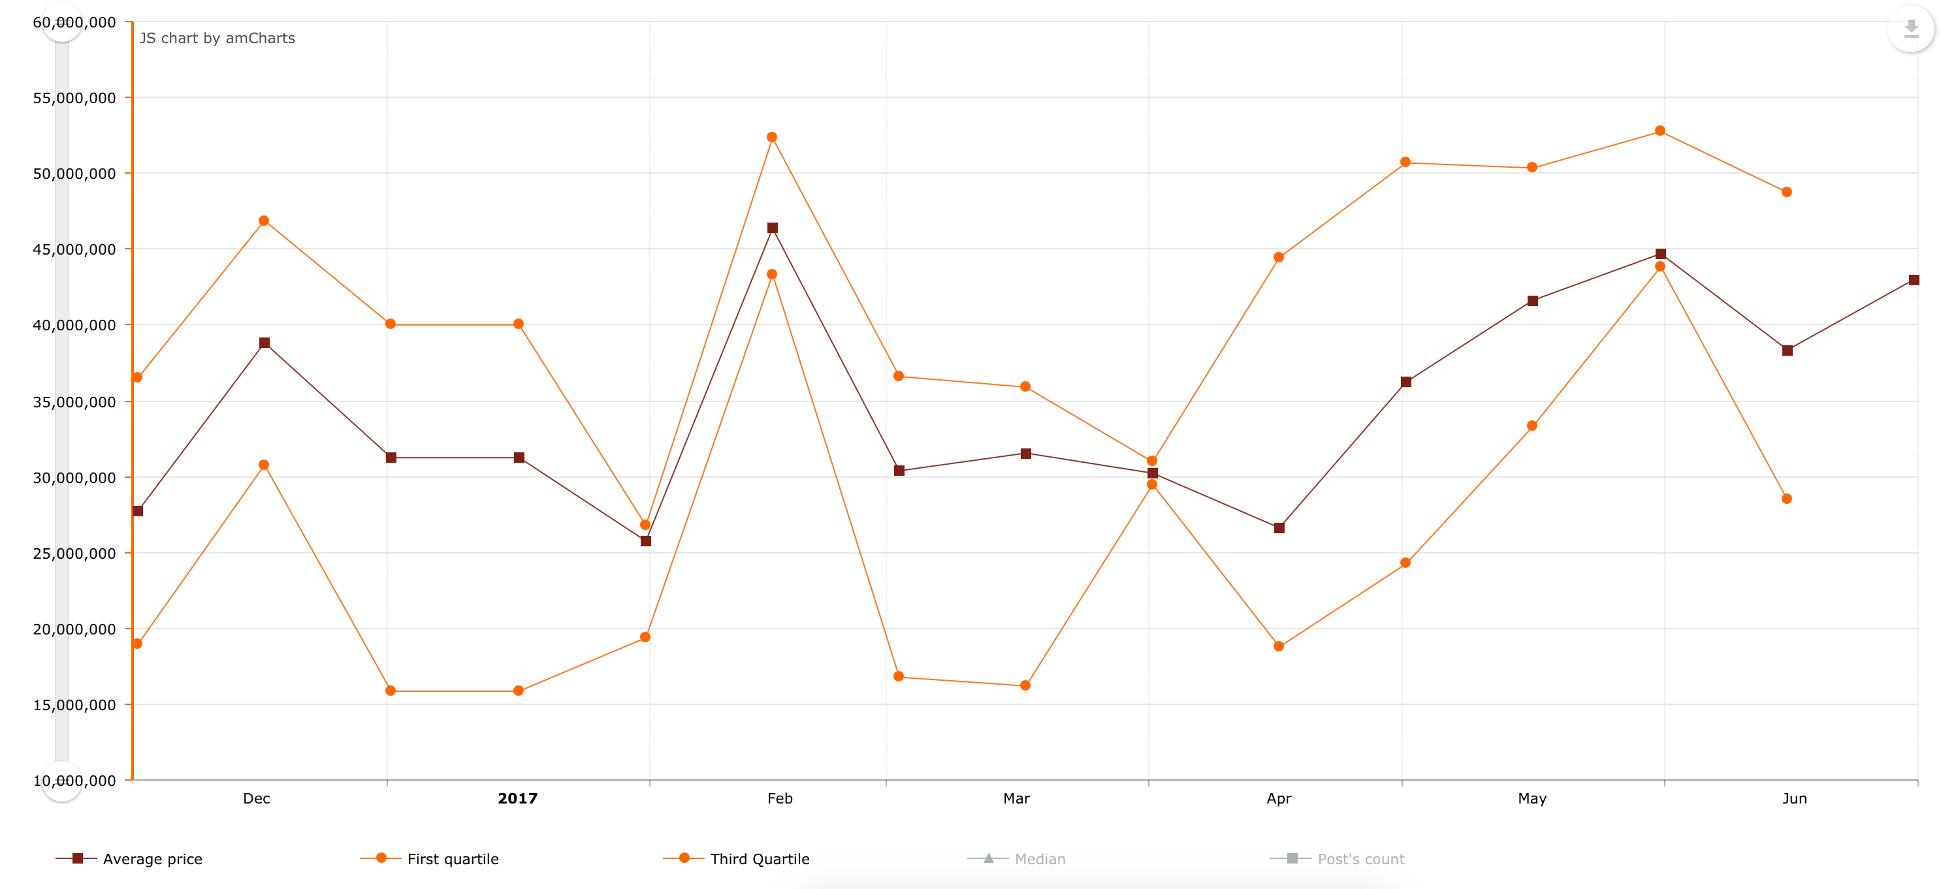

**Figure 57: Price trend of apartments for sale in district 5 between November 2016 and June 2017**

bottom of 25.7 in the end of January and 26.6 million in the middle of April, the average price of apartments for sale has risen to 43 million in June (**Figure 57**). Additionally, the first quartile and third quartile in this region are 28.4 and 48.7 million per square meter.

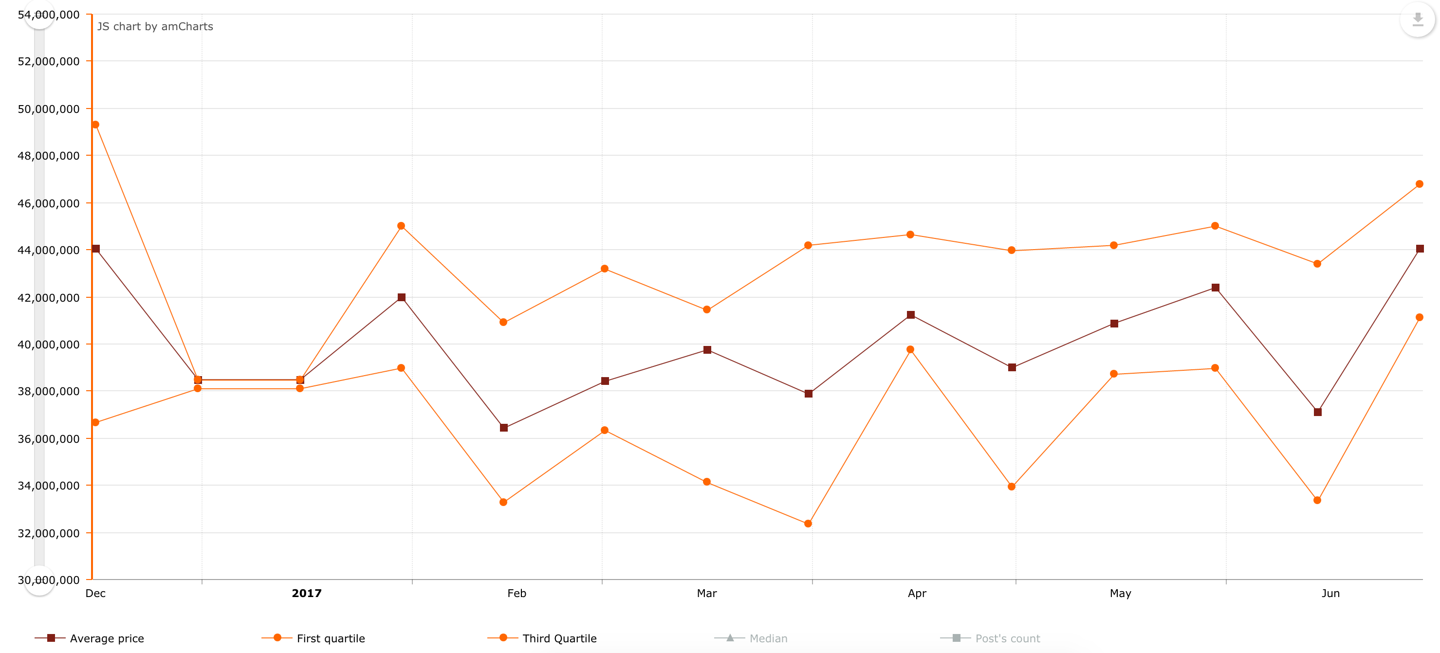

**Figure 58: Price trend of apartments for sale in district 10 between November 2016 and June 2017**

Another central district which also has a large number of apartments for sale is district 10. According to **Figure 58**, the average price of apartments for sale in district 10 from the end of 2016 seems to remain stable despite some fluctuation. The price tends to gather around 40 million per square meter. However, in the end of June 2017, the price of apartments for sale has increased slightly, and reach 44 million. Besides that, the first quartile and third quartile also are 41 and 46.7 million, respectively.

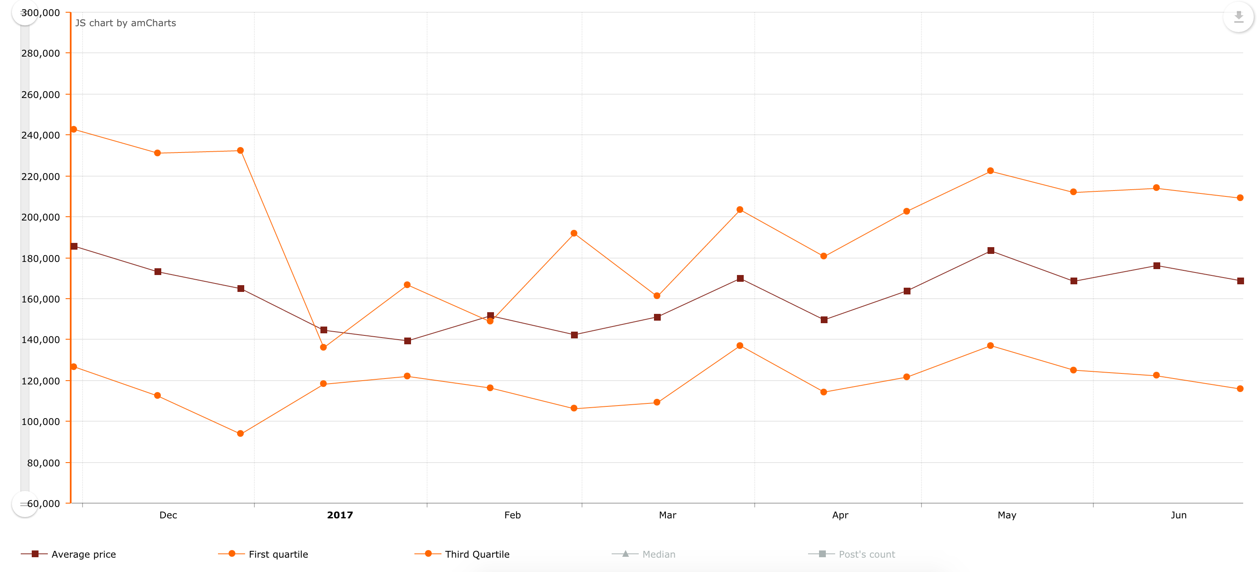

**Figure 59: Price trend of apartments for rent in district 7 between November 2016 and June 2017**

In terms of the rental housing market across Ho Chi Minh, due to the favorable location, most rental housing activities tend to take place in central dsitricts where people find it convient to go to work or school. However, in contrast to the bustle in the housing market of apartments for sale, apartments for rent do not attract customers as expected. Although making up the majority of aparments for rent, district 7 has seen a slight decline in the price of apartment for rents (at 168,764 VND per square meter in June 27, 2017 **Figure 59**). The first quartile and third quartiel of the district are 115,799 and 209,109 VND per square meter.

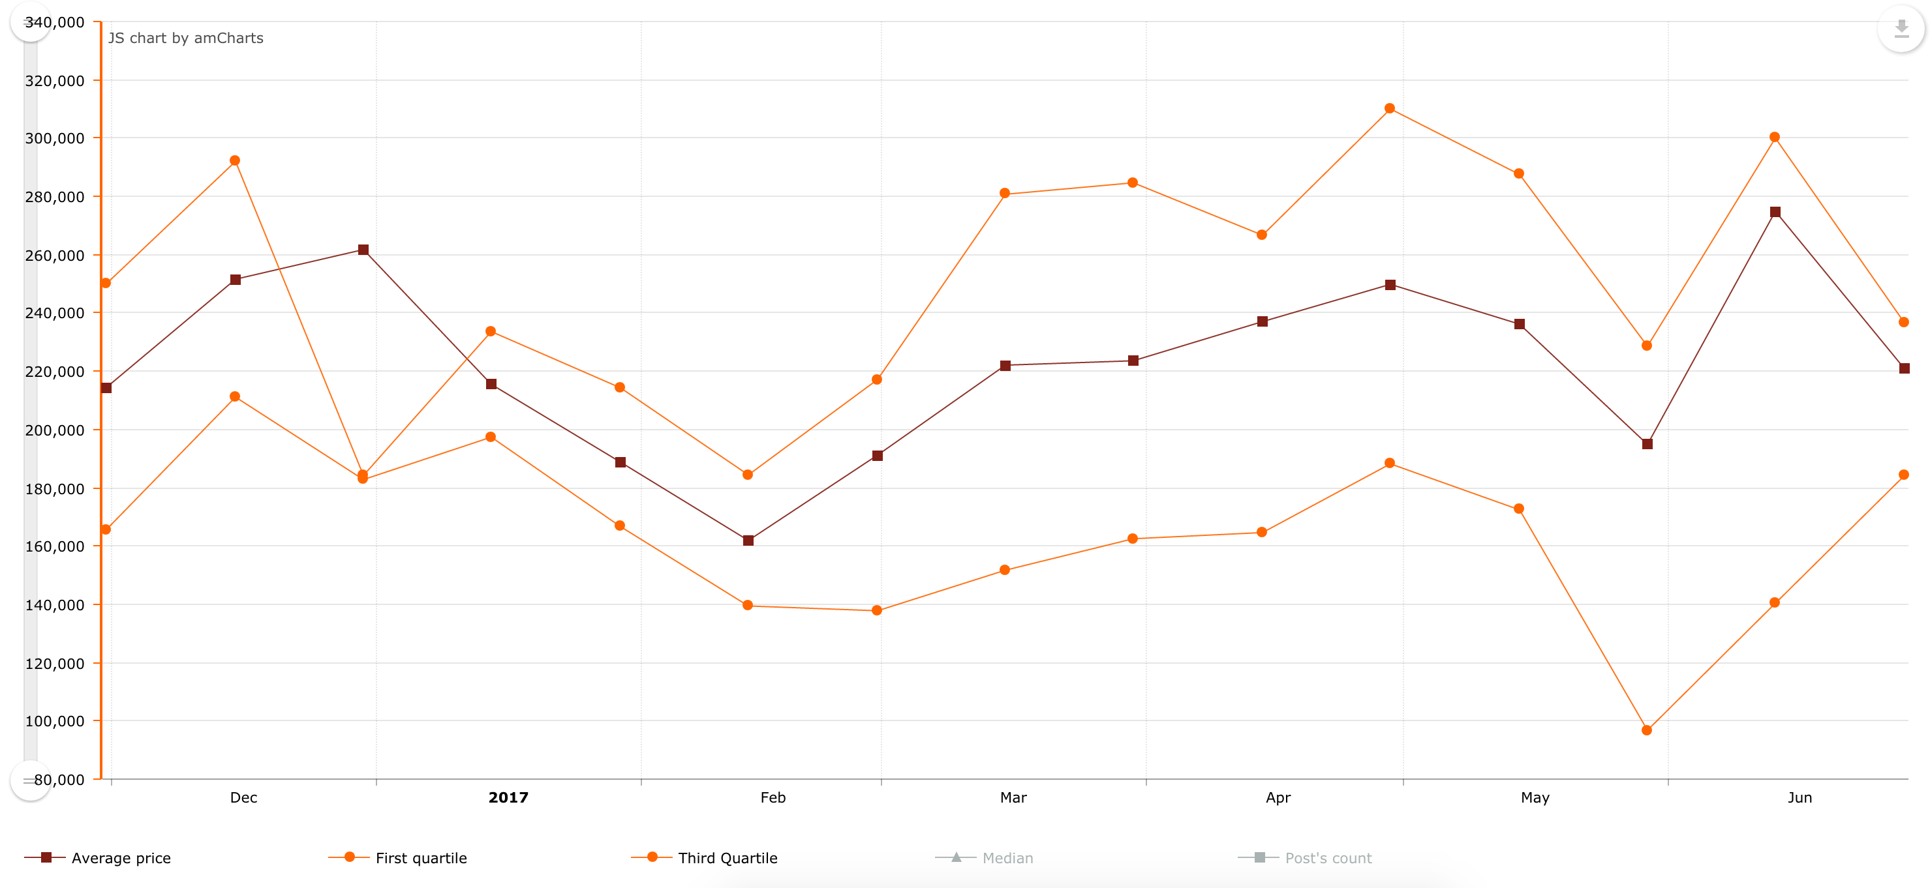

**Figure 60: Price trend of apartments for rent in district 1 between November 2016 and June 2017**

**Figure 60** shows the price trend of apartments for rent in district 1, being the central district and constituting more than 2400 rental listings. However, the real estate market in district 1 witnessed a slight fall in the average price of apartments for rent, at 220.800 VND per square meter. In addition, the first quartile and third quartile of average price of apartments for rent in district 1 are 184,210 and 236,562 VND per square meter.



**Figure 61: Mean and median price of apartments for sale in Hanoi between November 2016 and June 2017**

In Hanoi, due to the limited area, the housing market mainly focuses on the apartments, and most of the real estate activities belong to the apartment projects. According to **Figure 61**, Ba Dinh and Hoan Kiem are two top districts in Hanoi. While the mean price of Hoan Kiem (41.5 million) is higher than that of Ba Dinh (40.2 million), the median price of Ba Dinh (36.7 million) defeats that of Hoan Kiem (34.2 million).

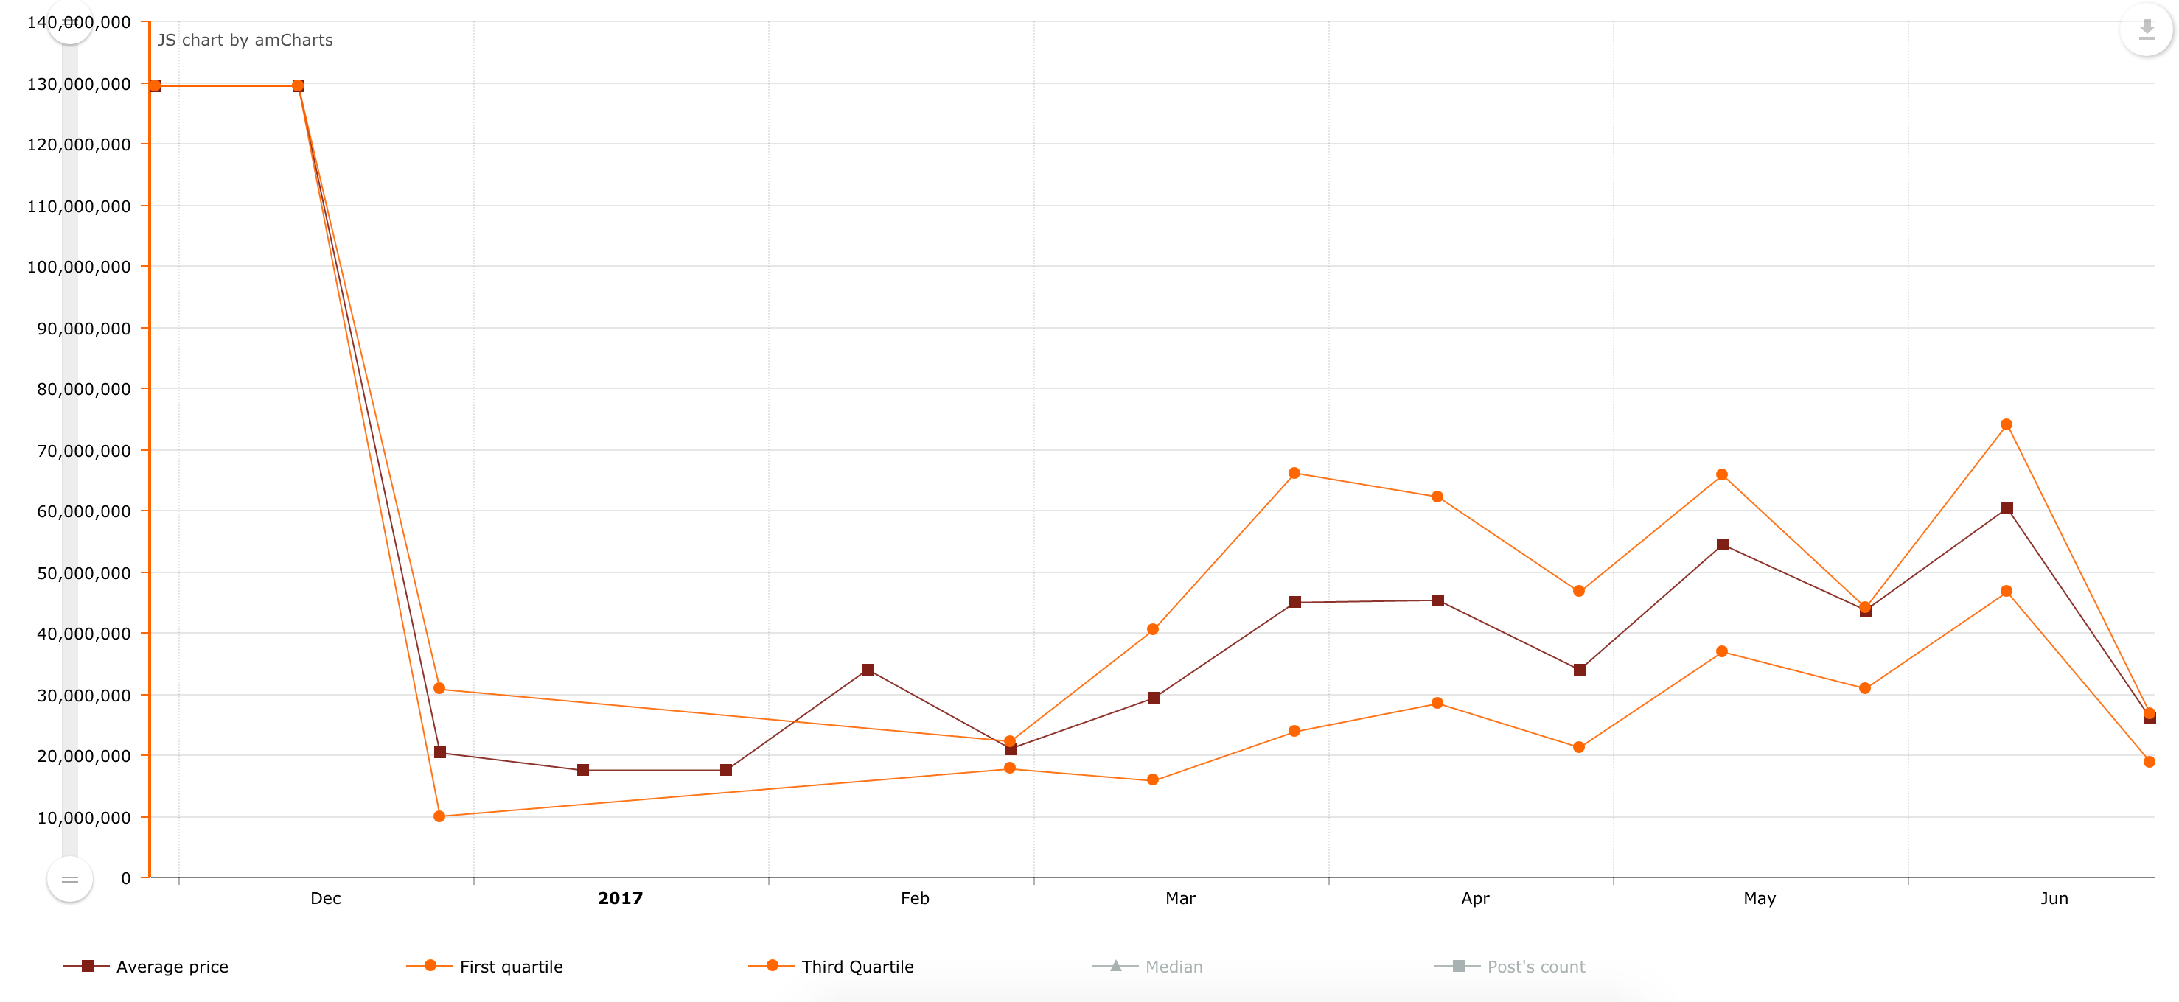

**Figure 62: Price trend of apartments for sale in Hoan Kiem between November 2016 and June 2017**

In Hoan Kiem, since the rise in March, the apartment price always stayed more than 30 million per square meter. Nonetheless, from the end of June, the price of apartment has tended to decrease, and the up-to-date price is nearly 26 million per square meter (**Figure 62**). Furthermore, the first quartile and third quartile of price in Hoan Kiem are 19 and 26.8 million per square meter.

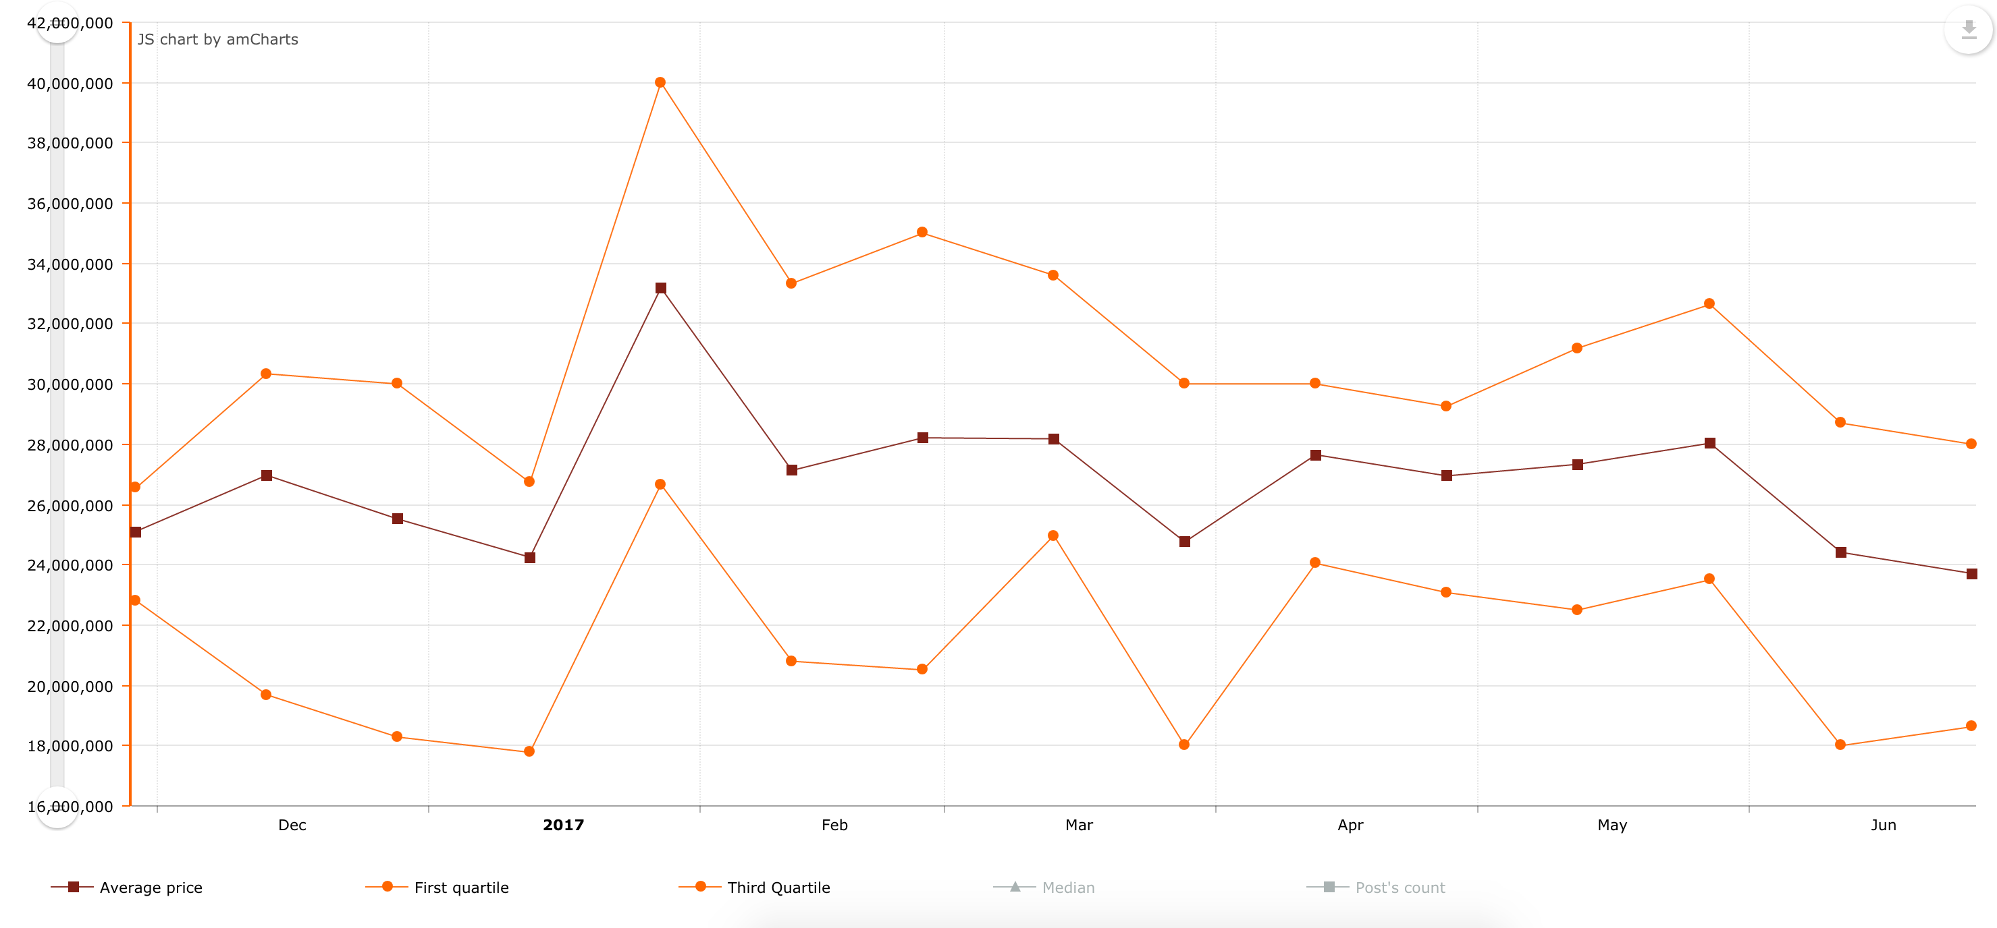

**Figure 63: Price trend of apartments for sale in Nam Tu Liem between November 2016 and June 2017**

Nam Tu Liem, for a long time, is known as a “hot spot” in the real estate market which attracts many investors. Nam Tu Liem is generally emerging as a new social-economic centre of Hanoi. Nonetheless, the average price of apartments in this district has decreased slightly recently, at 23.7 million per square meter **Figure 63**. Additionally, the first and third quartile of the price trend in the district are 18.6 and 28 million per square meter.

In terms of rental market in Hanoi, Thanh Xuan, Cau Giay and Dong Da play an important role in the market of the capital because they account for the majority of rental listings, with Thanh Xuan being 13.4%, and Cau Giay 24.8%, and Dong Da 15.9%.

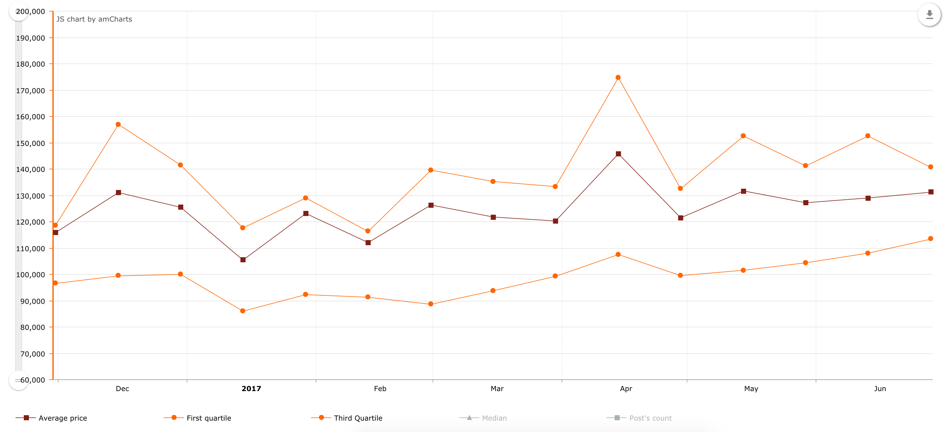

**Figure 64: Price trend of apartments for rent in Thanh Xuan between November 2016 and June 2017**

**Figure 64** shows the the price trend in the rental market regarding apartments for rent in Thanh Xuan. Look into the chart, from January 2017, despite a fluctuation with some slight augmentation and decline, in overall, the average price of apartments in Thanh Xuan has increased slowly, and reached 131,221 VND per square meter. When compared with the beginning of 2017, the first and third quartile also experience a slight increase, with first quartile being 113,402 VND and third quartile 140,625 VND per square meter.

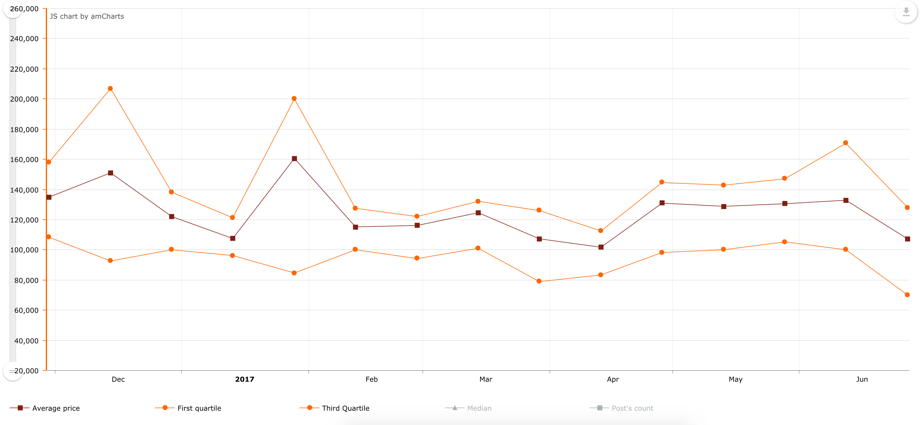

**Figure 65: Price trend of apartments for rent in Dong Da between November 2016 and June 2017**

Dong Da is another districts where most rental activities occur. The average price of apartments for rent in this district seem to be stable, congregating at 115,000 VND per square meter. At the moment, the apartment price for rent in this area is 107,235 VND per square meter, and tend to decrease in the near future **Figure 65**.

# Conclusion

## Result

The authors have learned the basic knowledge of web scraping and gain a background in data mining, including data cleaning, anomaly detection, and pattern detection. For data cleaning, we analysed multiple record linkage methods including Support Vector Machine, Decision Tree, Bayes, Neural network, and rule – based record linkage to understand their characteristic and find a method that is suitable for our case. For anomaly detection, we experimented with three methods to detect outlier, including standard deviation, interquartile range, and modified z – score. After many test, we concluded that modified z – score is a robust solution to detect outlier values that is not affected by extreme value and is suitable to our current need. Finally, from the processed dataset that we produced, we tried applying multiple data visualization methods to find the pattern underlying the real estate market.

The authors have built a system of crawlers to scrape data from six big real estate websites in Vietnam. Using this system, we have generated a dataset with around 350,000 listings of real estate, both for rent and for sale between November 2016 and June 2017. From this dataset, we extract the pattern and characteristic of the real estate market, including average price, highest, lowest price, and the deviation in data of each region, how price change over time, how location and real estate type affect a property’s price, how likely is it that a property in a region has its price fall in a certain range, what is the percentage in the market of each real estate type, and the pattern that brokers and real estate’s owners post their listings. Finally, we developed a website to visualize these pattern and characteristic to the public, together with extensive filtering options covering multiple aspect of a property like location, transaction type, and real estate type.

## Future Work

Currently, our dataset consists of only listings between November 2016 and June 2017, since we have only started scraping from November 2016, to a total of around 350,000 listings. Even though our dataset can be used to get a close insight to many regions (Ho Chi Minh and Hanoi), there are still a lot of regions that our dataset could not cover. Because of that, our target in the future is to continue scraping to further expand our dataset in other regions.

Furthermore, while we did store the description of each real estate listings, which could hold many information about the target, its current use is only as a weight to decide whether two listings are duplicated. For further progress, we aim to utilize this source of information using text mining and natural language processing to extract other details of a property.

# References

|  |  |
| --- | --- |
| [1] | S. R. O. V. NAM. [Trực tuyến]. Available: http://moj.gov.vn/vbpq/en/lists/vn%20bn%20php%20lut/view_detail.aspx?itemid=4769. [Đã truy cập 13 7 2017]. |
| [2] | savillis, “Market Briefs Q3, 2016 Ho Chi Minh City, Viet Nam,” 10 3 2016. [Trực tuyến]. Available: http://pdf.savills.asia/asia-pacific-research/vietnam-research/hcmc/hcmc-market-brief-q3-2016-en.pdf. [Đã truy cập 13 7 2017]. |
| [3] | J. L. LaSalle, “Vietnam Property Market Brief JLL Research 3Q16,” [Trực tuyến]. Available: http://www.joneslanglasalle.com.vn/vietnam/en-gb/Research/Vietnam%20Property%20Market%20Brief%203Q16%20-%20EN.pdf?ec70fbf1-ba8c-48d1-adec-871437a2fd83. [Đã truy cập 10 7 2017]. |
| [4] | P.Christen, “Automatic record linkage using seeded nearest neighbor and support vector machine classification ID - 6,” ACM, 2008. |
| [5] | T.Churches, P.Christen, K.Lim và J.x.Zhu, “Preparation of name and address data for record linkage using hidden Markov models,” *BMC Medical Informatics and Decision Making,* tập 2, pp. 9-9. |
| [6] | G. Boeing và P. Waddell, “New Insights into Rental Housing Markets across the United States: Web Scraping and Analyzing Craigslist Rental Listings,” *Journal of Planning Education and Research 1–20,* p. 20, 2016. |
| [7] | H. Wu, R. Luk, K. Wong và K. Kwok, “Interpreting TF-IDF term weights as making relevance decisions,” p. 26, 2008. |
| [8] | “Tf-idf :: A Single-Page Tutorial - Information Retrieval and Text Mining,” [Trực tuyến]. Available: http://www.tfidf.com/. [Đã truy cập 2 7 2017]. |
| [9] | A. Ariel, B. Bakker, M. d. Groot, G. v. Grootheest, J. v. d. Laan, J. Smit và B. Verkerk, “Record Linkage in Health Data: a simulation study,” *The Hague/Heerlen: Statistics Netherlands,* 2014. |
| [10] | S. Seo, “A Review and Comparison of Methods for Detecting Outliers in Univariate Data Sets,” University of Pittsburgh , 2002. |
| [11] | C. Leysa, O. Klein, P. Bernard và L. Licata, “Detecting outliers: Do not use standard deviation around the mean, use absolute deviation around the median,” *Journal of Experimental Social Psychology,* tập 49, số 4, pp. 764-766, 2013. |
| [12] | G. Upton và I. Cook, “Understanding Statistics,” *Oxford University Press,* p. 55. |
| [13] | “Interquartile Ranges & Outliers,” 2010. [Trực tuyến]. Available: http://www.purplemath.com/modules/boxwhisk3.htm. [Đã truy cập 1 7 2017]. |
| [14] | “Scrapy,” [Trực tuyến]. Available: https://scrapy.org/. [Đã truy cập 19th June 2017]. |
| [15] | J. Beel, B. Gipp, S. Langer và C. Breitinger, “Research-paper recommender systems: a literature survey,” *International Journal on Digital Libraries,* tập 17, số 4, pp. 305-338, 2016. |
| [16] | “Data Modeling Introduction,” [Trực tuyến]. Available: https://docs.mongodb.com/manual/core/data-modeling-introduction/. [Đã truy cập 11th June 2017]. |
| [17] | “Jepsen: MongoDB,” [Trực tuyến]. Available: https://aphyr.com/posts/284-call-me-maybe-mongodb. [Đã truy cập 11 June 2017]. |
| [18] | “BSON – Binary JSON,” [Trực tuyến]. Available: http://bsonspec.org/. [Đã truy cập 11 June 2017]. |
| [19] | “GitHub list of JavaScript repositories, sort by descending stars,” [Trực tuyến]. Available: https://github.com/search?l=JavaScript&o=desc&q=stars%3A%3E1&s=stars&type=Repositories. [Đã truy cập 12 June 2017]. |
| [20] | “Angular Conceptual Overview,” [Trực tuyến]. Available: https://docs.angularjs.org/guide/concepts. [Đã truy cập 12 June 2017]. |
| [21] | “Node.js w/1M concurrent connections!,” [Trực tuyến]. Available: http://blog.caustik.com/2012/08/19/node-js-w1m-concurrent-connections/. [Đã truy cập 13 June 2017]. |
| [22] | “NPM Home page. Retrieve June 13, 2017 from,” [Trực tuyến]. Available: https://www.npmjs.com/. [Đã truy cập 13 June 2017]. |
| [23] | B. Silverman, trong *Density Estimation for Statistics and Data Analysis*, London, Chapman & Hall/CRC, 1986, p. 48. |
| [24] | V. A. Epanechnikov, “Non-Parametric Estimation of a Multivariate Probability Density,” trong *Theory of Probability & Its Applications*, 1969, pp. 153-158. |
| [25] | N. Department, “Cảnh báo sốt giá đất ảo ở vùng ven TP.HCM,” 22 5 2017. [Trực tuyến]. Available: http://vtv.vn/kinh-te/canh-bao-sot-gia-dat-ao-o-vung-ven-tphcm-20170522204629843.htm. [Đã truy cập 2 7 2017]. |
| [26] | H. J. Kenneth, “Symbiotic Relationships: Pragmatic Acceptance of Data Scraping,” *Berkeley Technology Law Journal,* p. 29, 1 1 2014. |